Northrop Grumman Robotic Drilling Arm

Final Design Report

Brandon Knutson – Manufacturing Engineer
Daniel Cooke – Financial Manager
Mason Goodman – Test Engineer
Mica Nellis – Logistics Manager
Russel Stringham – CAD Engineer
Isaiah Padilla – Project Manager

Fall 2023-Spring 2024



Project Sponsor: Northrop Grumman Space Systems
Sponsor Mentor: Andrew Acosta and Arjun Benerji
Instructor: David Willy

DISCLAIMER
This report was prepared by students as part of a university course requirement. While considerable effort has been put into the project, it is not the work of licensed engineers and has not undergone the extensive verification that is common in the profession. The information, data, conclusions, and content of this report should not be relied on or utilized without thorough, independent testing and verification. University faculty members may have been associated with this project as advisors, sponsors, or course instructors, but as such they are not responsible for the accuracy of results or conclusions.

EXECUTIVE SUMMARY
Northrop Grumman Space Systems initiated a project aimed at developing a robotic drilling arm capable of precisely locating drilling positions on any cylinder, crucial for assembling their launch vehicles. These vehicles utilize cylindrical composite materials to bolt secondary structures, serving as the backbone for connecting the entire launch structure. The drilling arm must account for varying cylinder sizes and materials while ensuring it can generate enough force to penetrate the targeted composite material, specifically aluminum in this instance. Initial financial provisions for this endeavor stand at $5,000, with the possibility of an additional $2,500 depending on design progression. To ensure adequate funding, the team has initiated fundraising efforts, targeting a sum of $750, which equates to 10% of the potential total budget.

The significance of this project lies in Northrop Grumman's quest for efficiency in design and production. The robotic arm is anticipated to streamline their design cycle, enabling the company to handle more processes in-house. Presently, Northrop Grumman often outsources specific tasks or tests to out-of-state entities. The robotic drilling arm's introduction is expected to curtail such dependencies, reducing the time lag between design and production. Throughout the project's conceptualization, the design underwent several revisions, with the team oscillating between multiple robotic arm models, ultimately settling on a four-degree freedom robotic drilling arm with spherical coordinates. This design was chosen for its adaptability and accuracy, even if it presents complexities in its realization.

Currently, the project is progressing as planned, with the team continuously adapting to new insights and challenges. Although certain design choices may appear redundant or challenging, the team remains committed to realizing a versatile and effective robotic arm that not only meets the client's specifications but also stands out during the Northrop Grumman Design Day. The collective objective is to provide a solution that can be feasibly integrated into Northrop Grumman's in-house operations.

At the time of writing, the team’s product can rotate in a full circle, operating the drill arm under full power, be programmed with drilling coordinates from a human operator, and drilling through a plate of aluminum on its own.

TABLE OF CONTENTS
Contents
DISCLAIMER 1
EXECUTIVE SUMMARY 2
TABLE OF CONTENTS 3
1 BACKGROUND 1
1.1 Project Description 1
1.2 Deliverables 2
1.3 Success Metrics 3
2 REQUIREMENTS 4
2.1 Customer Requirements (CRs) 4
2.2 Engineering Requirements (ERs) 5
2.3 House of Quality (HoQ) 6
3 Research Within Your Design Space 7
3.1 Benchmarking 7
3.2 Literature Review 9
3.2.1 Isaiah Padilla 9
3.2.2 Brandon Knutson 12
3.2.3 Daniel Cooke 14
3.2.4 Mason Goodman 16
3.2.5 Mica Nellis 18
3.2.6 Russel Stringham 21
3.3 Mathematical Modeling 23
3.3.1 Joint 1 – Brandon Knutson 23
3.3.2 Joint 2 – Mica Nellis 24
3.3.3 Joint 3 – Russel Stringham 24
3.3.4 Joint 4 and 5 – Brandon Knutson 25
3.3.5 Torque Calculation – Daniel Cooke 26
3.3.6 Electrical – Mason Goodman 28
4 Design Concepts 29
4.1 Functional Decomposition 29
4.2 Concept Generation 29
4.2.1 Initial Process of Overall Drill Arm Concept Generation 29
4.2.2 Electrical Component Wiring 30
4.3 Selection Criteria – Top Level 31
4.4 Concept Selection 31
4.4.1 Base Rotation 31
4.4.2 Gear System for Joint 2 and 3 32
4.4.3 Wiring Selection 32
5 Schedule and Budget 33
5.1 Schedule 33
5.2 Budget 37
5.3 Bill of Materials (BoM) 38
6 Design Validation and Initial Prototyping 40
6.1 Failure Modes and Effects Analysis (FMEA) 40
6.2 Initial Prototyping 43
6.2.1 Design Prototype 1 43
6.2.2 Design Prototype 2 43
6.2.3 Design Prototype 3 44
6.3 Future Testing Potential 45
7 Final Hardware 46
7.1.1 Final Physical Design 46
7.1.2 Final Assembly – Russel Stringham 46
7.1.3 Joint 1 – Brandon Knutson 47
7.1.4 Joint 2 – Mica Nellis 48
7.1.5 Joint 3 – Russel Stringham 49
7.1.6 Joints 4 and 5 – Brandon Knutson 50
7.1.7 Electrical 51
8 Final Testing 52
8.1 Top level testing summary table 52
8.2 Detailed Testing Plan 52
8.2.1 Torque Speed Curves 52
8.2.1.1 Summary 52
8.2.1.2 Procedure 52
8.2.1.3 Results 52
8.2.2 Power and Efficiency 53
8.2.2.1 Summary 53
8.2.2.2 Procedure 53
8.2.2.3 Results 53
8.2.3 Spindle Speed 54
8.2.3.1 Summary 54
8.2.3.2 Procedure 54
8.2.3.3 Results 54
8.2.4 Refined Joint Displacement 55
8.2.4.1 Summary 55
8.2.4.2 Procedure 55
8.2.4.3 Results 56
8.2.5 Specification Sheets 56
9 Future Work 57
10 CONCLUSIONS 59
11 REFERENCES 60
12 APPENDICES 64
12.1 Appendix A: Top Level Testing Design Summary 64
12.2 Appendix B: Bill of Materials 65
12.3 Appendix C: Failure Modes and Effects Analysis 70

BACKGROUND

In this chapter a summary of this project as well as all important deliverables that were expected of the team throughout the duration of the design process. There were various requirements and constraints that were applied to this project from our instructor as well as our project sponsors that define the overall success of this project, also known as the most viable product (MVP). The budget that was given heavily impacted this design as well as how it was made so this will also be included in this chapter.

Project Description

Northrop Grumman Space Systems proposed the creation of a robotic drilling arm, with the primary objective being to design an arm with a drill tool capable of locating positions on any cylinder to aid in drilling. Northrop Grumman designs and builds launch vehicles that are responsible for launching satellites into space. These launch vehicles include cylindrical composite materials to bolt secondary structures which is what is used to connect entire launch vehicles together. The team’s drill, as stated previously, will need to locate positions on any cylinder to assist with drilling and apply enough force to drill through a composite material. For the scope of this project, which has been altered since the original design proposal, the main objective is to drill through a quarter inch plate of aluminum during testing and real-world simulation which will prove that the robotic drilling arm can complete the intended task.

The NAU engineering team is designing a robotic drilling arm that is required to perform various tasks that include but are not limited to being human input responsive, drilling through composite material, with various bolt clearances. Various concepts were considered throughout the design process and were eventually ruled out through failure modes and effects analysis (FMEA), testing, as well as the expected MVP of the product and benchmarking of the individual subsystems. After all mathematical modeling, benchmarking was complete the team decided on a five degree of freedom (DOF) robotic drilling arm that meets all customer and engineering requirements to ensure the overall success of the design. Each “joint” within the robotic arm will have different mannerisms and ultimately allow for the end effector of this robot to complete the drilling action. Below a list can be seen of each joint as well as the task that is expected.
- Joint 1: Base axis of the robot allowing for movement from left to right.
- Joint 2: Allows for the arm to move in the x-direction forward and backward for horizontal reach.
- Joint 3: Provides the ability similarly to joint two for movement in the x-direction but for vertical reach.
- Joint 4: Allows for the “wrist” motion to be completed keeping the end effector perpendicular to drilling surface.
- Joint 5: End effector drilling rotation.

The budget for this project has a small amount of room for change as the design progresses, allotted an initial amount of $5,000.00 pending design decisions throughout the design process potentially having an additional $2,500.00 if the design requires more than the initial amount. As the design process has progressed, the team ended up requesting the full budget of $7,500.00. Per David will it was expected of the team to fundraise 10% of the overall budget, this was $750.00 for us, upon using self donations, ASME donations, as well as a gofundme, the team fundraised $1,295.00.

This project is important because Northrop Grumman Space Systems is always looking for what is more efficient in regard to speed and efficiency in designing. By creating this robotic arm, the overall design cycle will improve and add adds to the internal availability within their company which in turn drives their designs. Northrop Grumman was in search of finding a design that allowed for easier manufacturability as well as “wanting to do things in house”, as stated by the team’ clients, and the team creating a robotic drilling arm for these launch vehicles allows for a major step in that direction. By
having a design such as what is proposed for this capstone allows for Northrop Grumman to avoid the
time factor, meaning that they often have to go out of state to get certain things made or tested, and
having such an impactful device the time to accomplish certain deliverables will be shortened immensely.

Deliverables
The team is tasked with several deliverables throughout this course, some of which are more important than others. Although each deliverable is imperative to the success of the team as well as this project, there are a select few that will directly impact what is designed, how the drilling arm is designed, and why specific design choices are made. The most impactful deliverable throughout this course are the first and second prototypes as completing these prototypes will show what the team has planned to implement different requirements set by the clients into the design that the team was tasked with. Along with that each prototype is a milestone that is completed to show the overall progress of the design, meaning that within the first prototyping process the team knows the standings for completing this project as well as what is to come leading to prototype two. Following this the website being created will also heavily aid in the success of this project, it will allow for various important members of the completion and success of this project to see the progress being made. Websites can also allow for different networking opportunities for the team, it can be extremely helpful when considering the 10% fundraising amount that is included within the total budget. The reason for this is because when asking a business/person to donate money, materials, or discounts whomever they are will likely want more information in regard to who they are giving this to, a website can allow for any person interested in this project to have easy access to what is being done and why it is important. These mentioned deliverables were to ensure success for the duration of the first semester of the design process. Following the first semester it was required of the team to have a completed robotic drilling arm that would drill through aluminum by the completion of semester two. To better understand these deliverables as well as the deliverables asked of us by Northrop Grumman two tables can be seen below.
Northrop Grumman Space Systems is also asking the team to complete different deliverables by certain deadlines. There is no deliverable within what is being asked that is more important than the other regarding the clients, they each hold extreme value and importance. The team is tasked with completing Preliminary Design Review (PDR) and Critical Design Review (CDR) presentations that may be virtual or in person. The PDR presentation is necessary in showing the groundwork for what the design will likely be, like prototype one within this course it will be a deliverable that shows overall progress and intentions for the design. On the contrary, the CDR presentation will only happen once the team has a completed prototype allowing for a much more refined and rounded idea of the overall design.
Following all deliverables throughout the course as well as with the clients the team will participate in Northrop Grumman Design Day. This is a competition that includes, NAU, ASU, U of A, and ASU Polytechnic, all teams will bring their final design and perform what is being asked for by the clients, this can be seen in section 1.1, and what the team has been designing towards throughout the duration of the course. Thus, having a design that fits a certain size constraint as well as fully function within all aspects that the team was tasked with.
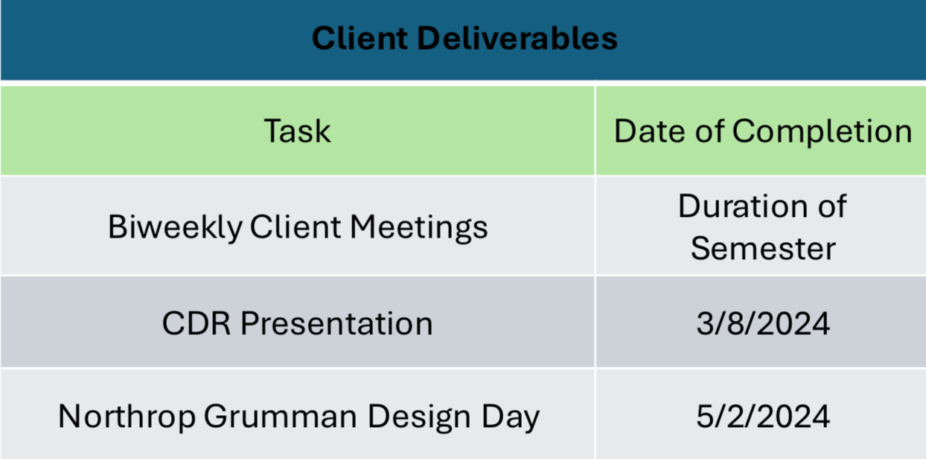
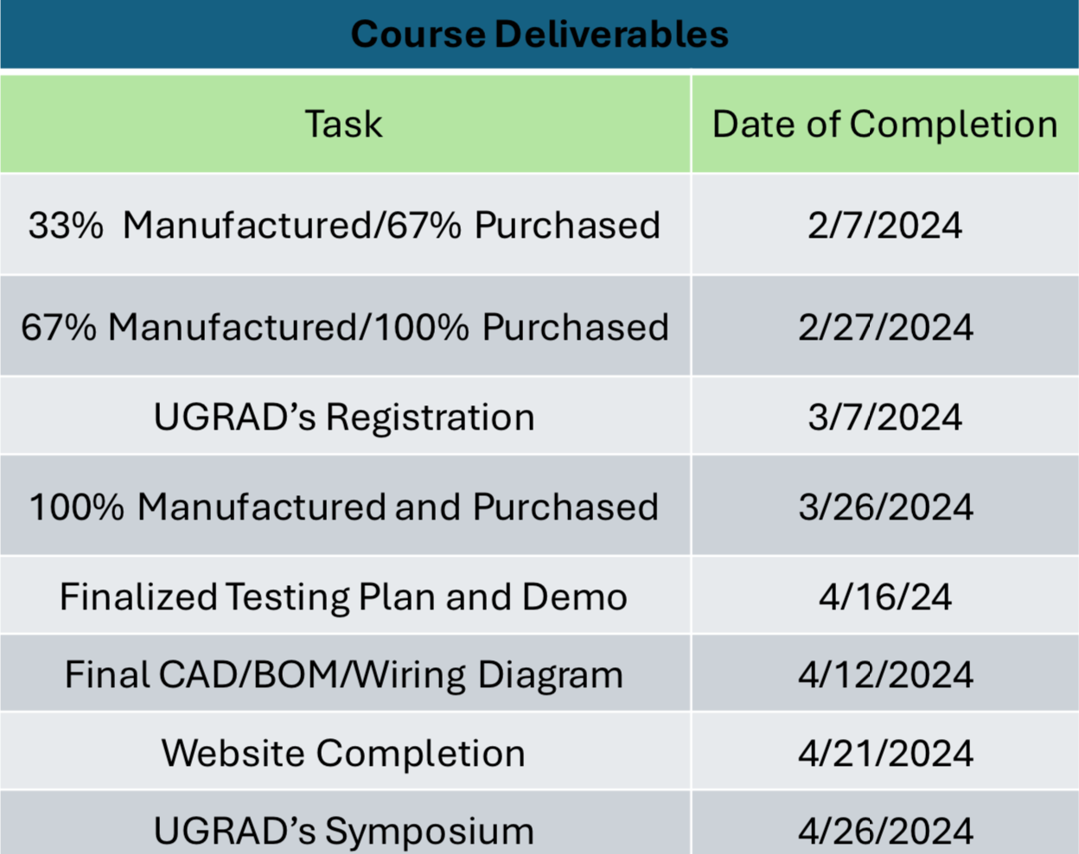
Table 1.2.1: Important course deliverables. Table 1.2.2: Client deliverables.

Success Metrics
For this produce to be successful the team must be able to complete and meet most if not all customer and engineering requirements. The main objective of the robotic drilling arm is to ensure that it can drill through a ¼” plate of aluminum. Along with this to be successful the drill must run appliance household power (no hydraulics), be cost effective, be human input responsive (HIR), and lastly be portable. These requirements alone will ensure that the drill can move to a specific position and complete the drilling operation, thus making the robotic arm successful. The robot itself is powered through a coding program using an Arduino mega and its software that is directly powered with a power supply within the electrical box to ensure that household appliances will not be an issue going further. To make this robot portable the team purchased and cart that is on wheels while also locking the most bottom plate into place on this cart. The team is expected to bring the entire robot apparatus to the UGRAD’s Symposium as well as to Northrop Grumman Design Day, and having this secured while also being moveable was imperative. Through various calculations and modeling renditions the team was able to determine that the robot to be built would complete the necessary requirements to ensure success.

REQUIREMENTS
The purpose of this chapter is to discuss and quantify the requirements and procedures that the final product must be able to perform as gathered from meetings with the client. The first section of the chapter details the customer requirements as gathered from client meetings as well as the initial project proposal. The second section takes the customer requirements and turns them into quantifiable engineering requirements. These engineering requirements are necessary to define prior to the design phase, as all design aspects revolve around the final product meeting or exceeding these engineering requirements. The engineering requirements are the fundamental basis of all future engineering calculations. The final section of this chapter

The project proposal defines the objective of the final product as an articulating arm drill tool that self-locates and is capable of applying enough force to drill holes through the inside of a composite cylinder. The project is divided into two parts. Project A, the higher priority project, requires the team to focus on the self-locating aspect of the drilling arm, which would allow in-house technicians to mark the exact location of a desired hole. Project B emphasizes the entire articulating arm, which should be able to drill horizontally at any location within the cylinder.

Customer Requirements (CRs)
Essential Customer Requirements
- Drilling end effector must reach a maximum diameter of 50 inches and a maximum height of four feet.
This is the maximum size cylinder that the drill will be used for. It was discussed during a client meeting that the minimum diameter may be 40 inches, with a minimum height of two feet. However, the main goal is to reach the original work volume as explicitly stated in the client meeting.
- Drill must be able to drill through a composite material equivalent to ¼ ‘’ aluminum at an angle perpendicular to the surface.
The real product will be drilling through a carbon-fiber composite material, however for the purposes of this project, the clients stated that the team could use ¼’’ aluminum for design tests.
- Drill must be human input responsive.
It is expected that a technician will be able to send the hole locations to the programmable software. The drill will then be able to articulate to the exact locations without any further intervention from the technician.
- Entire drilling apparatus must be portable.
A two-man team of technicians must be able to roll the drill to a desired manufacturing location where the cylinder will be dropped in around it before the drilling operation.
- Drill must have an emergency stop override function (e-stop).
In an event where the machine overheats or experiences any other catastrophic failure, it must be capable of shutting down without the need for human intervention.
- Drill must run strictly on electric power.
The drill will not have access to hydraulic lines; therefore, it should only run on a standard household appliance power supply.
- Drill must be able to work continuously throughout a 10-hour day without maintenance.
- Entire project cost must fall within the $5,000 budget, with the opportunity to increase to $10,000.
The stated budget for the project is $5,000, however if the client considers it to be beneficial to the team, the budget will increase to as much as $10,000.

Non-essential Customer Requirements
- End effector should have multiple drill bits for different job types.
Various jobs will require different sized holes, therefore requiring different drill bits.
- Drill should be capable of drilling in various directions, on varying surfaces, including flat plates or on the interior of a cone.
It is the goal of the clients to implement the technology developed within this project for more extensive jobs, like flat plates and conical surfaces.
- User interface with preprogrammed settings for known jobs.
Ideally, a technician would be able to use a digital interface that would allow for a preprogrammed setting to be selected. However, it is likely that the G-code would be sent from a laptop to the robot prior to job execution.

Engineering Requirements (ERs)
The following engineering requirements were developed by the team as a means of achieving the customer requirements as mentioned above. The majority of these engineering requirements were derived from calculations made by the team throughout the design process of the project.
- Drilling must meet a minimum tolerance of .003 inches.
- The drill must not exceed a maximum deflection of more than .1 inches at the tip of the end effector.
- The drill or spindle must spin at a minimum of 3000 rotations per minute.
- The drill must apply 153 N-m of torque.
- The end effector must push the drill bit against the drilling surface with a minimum force of x lbs.
- The joint motors must be able to supply 180 N-m of torque.
- The motor holding torque must be 150 N-m with the gearbox included.
- The base rotation must have a range of motion of 360 degrees.
- Additional joint motors must have a range of motion of 180 degrees.
- Entire portable assembly must weigh no more than 150 pounds.
- Entire assembly must cost less than $5,000 (possibly $10,000)
- Drill bits must be able to withstand 10 jobs per day before replacement.
- All other robot arm elements and hardware must be able to withstand 100 total jobs before replacement or routine maintenance.

House of Quality (HoQ)
The House of Quality (HoQ) is displayed below in Figure 2.1 as a foundational concept in the Quality Function Deployment (QFD) methodology, a structured approach to product design and development. The House of Quality visually represents how customer requirements relate to specific design attributes or features of a product. Its structure, resembling a house, consists of several components: the customer's needs or "whats" on the vertical side, the product's technical requirements or "hows" on the horizontal side, and a matrix in the middle showing the relationship between the two. The "roof" of the house represents the interactions between technical requirements, and the "foundation" or the bottom part often includes benchmarking against competitors. The objective of the House of Quality is to ensure that the voice of the customer is systematically and comprehensively translated into the design of a product or service, thereby enhancing customer satisfaction, and minimizing design iterations.

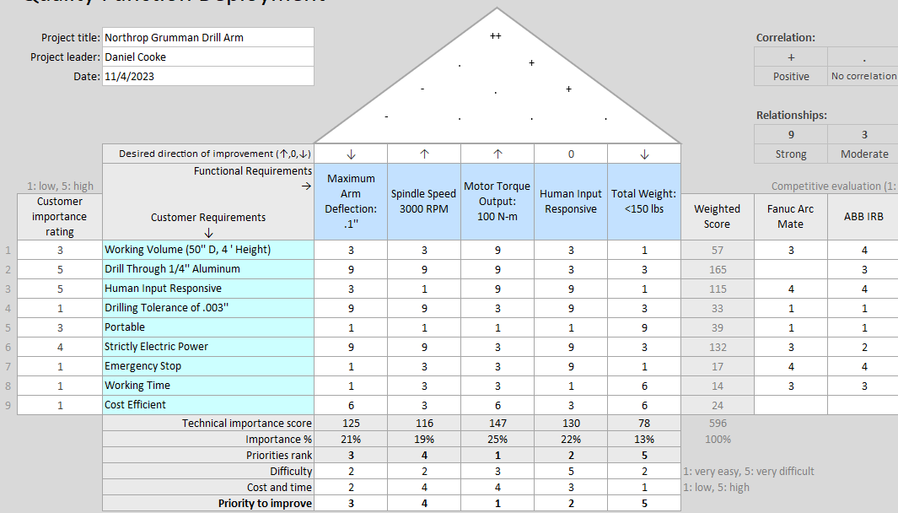

The updated house of quality depicts changes in the functional requirements associated with the project. From the engineering calculations, the team computed the necessary minimum functional outputs for the minimum viable product. Given the drilling tolerance of .003’’, it was determined that the maximum allowed deflection during the drilling operation should be .1’’ to allow for more error with the spindle. From research it was determined that the optimal drilling speed through quarter inch thick aluminum is 3000 rotations per minute. Given the predicted weight of the arm along with a maximum spindle weight of 12 pounds, the required torque output from the stepper motors is 100 N-m. This will only be achievable with a gear box of 50:1 gear reduction. The entire system will need to be portable and capable of being locked into placed prior to the drilling operation. It is assumed that it will be able to be rolled into the desired location by no more than two people, and therefore it should weigh no more than 150 pounds total. At the bottom of the QFD, the largest improvement priority is the motor torque output. If the motors are unable to hold the robot arm, let alone move it vertically in its most extended state, no other function is achievable. The second most important function is the automated system. The main idea of the project is to develop a self-locating robotic arm, prior to making it capable of drilling, so this is an essential function.

Research Within Your Design Space

Benchmarking

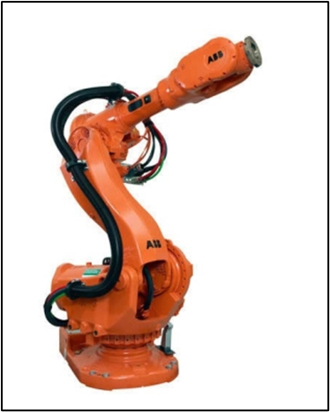
Figure 1: 6 DOF Primary Inspiration
Figure 1 displays one of the original benchmarking concepts viewed by the team as an inspiration for the the robotic arm to begin the design process. This arm contained many subsystems that the team felt was necessary for the original design, such as the electrical system, mechanical movement system, end effector implementation, and coding suite. This had a sleek and highly complicated look to the design efforts, and thus was treated as the primary source of what the team desired for the end product [1].
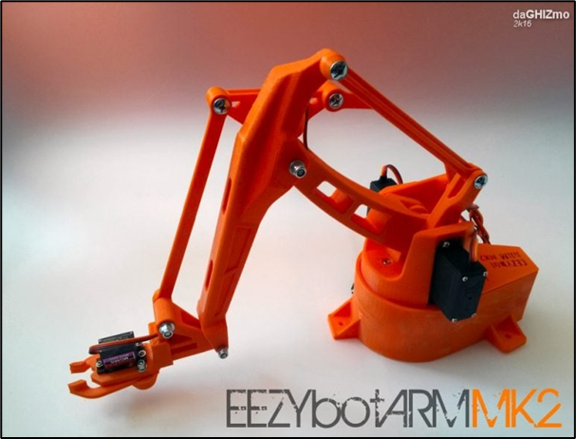
Figure 2: 6 DOF Alternative Inspiration
The team felt it necessary to refer to multiple design types and thus found this alternative build shown in Figure 2 above for a 6 DOF robotic arm. This featured a lighter overall system design with more exposed parts but greater overall dependence on simple mechanical elements for movement rather than outright electrical [2].

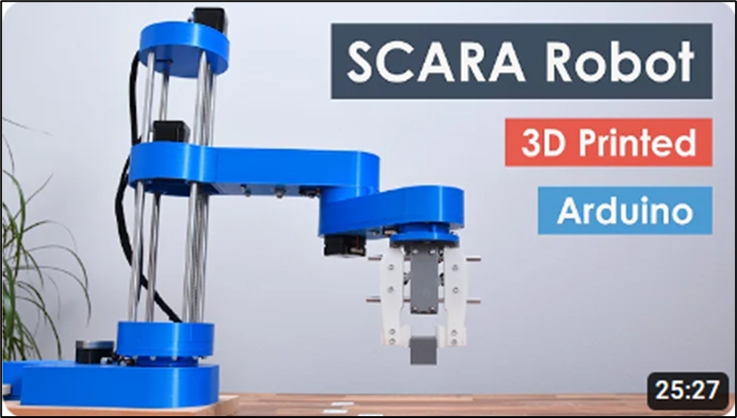
Figure 3: Non 6 DOF Robotic Arm Inspiration
The third benchmarking arm, shown in Figure 3 above, was used to reference a robotic arm implementation that did not have 6DOF [3]. The team felt it necessary to have this kind of inspiration in case it was decided to focus on a less mathematically complicated design. This system offers more flexibility in design and less rigidity in calculations [3].

Literature Review

Isaiah Padilla
[4] R. G. Budynas and J. K. Nisbett, “Chapter 9 - Welding, Bonding, and the Design of Permanent Joints,” in Shigley’s Mechanical Engineering Design, 11th edition, SI units, 11th ed, S.l., NY: MCGRAW-HILL EDUCATION (AS, 2020, pp. 485–612
This chapter discusses joining processes like welding, brazing, soldering, cementing, and gluing are vital in modern manufacturing, especially when assembling or fabricating parts. These methods are especially cost-effective for thin sections, as they eliminate the need for individual fasteners and associated assembly costs. Some of these processes even allow for speedy machine assembly. In the past, riveted permanent joints were commonly used for fastening steel shapes, with the captivating process of hot rivets being thrown and pneumatically hammered. This chapter was useful for guiding the team on how best the robotic drilling arm can be assembled and held together.

[5] R. G. Budynas and J. K. Nisbett, “Chapter 4 - Deflection and Stiffness,” in Shigley’s Mechanical Engineering Design, 11th edition, SI units, 11th ed, S.l., NY: MCGRAW-HILL EDUCATION (AS, 2020, pp. 173–219
All materials deform under stress, either elastically or plastically. The rigidity of a body depends on the context; for instance, a wire rope can be both flexible and rigid depending on the type of load applied. The importance of understanding deformation becomes clear in design scenarios. For example, snap rings must be both flexible for assembly and rigid for holding parts. In transmissions, excessive flexibility in shafts can lead to malfunction and premature wear. Similarly, in the steel industry, rolls need precise curvature to produce uniform sheet thickness, requiring knowledge of how much they'll bend during the process. Many times, the design of load-bearing components is based on deflection rather than stress limits. This chapter delves into the distortion of individual bodies due to their shape and load and touches upon the behavior of body groups. The chapter covers spring rates, tension, compression, torsion, deflection due to bending, elastic stability, shock, and impact. This has been helpful for guiding the team on how to calculate the deflections of the robotic drilling arm components, as well as to calculate how the robotic arm will react when experiencing high amounts of torque during drilling.

[6] G. R. Reddy and V. K. Eranki, “Design and Structural Analysis of a Robotic Arm,” thesis, Karlskrona, 2016
This thesis paper discusses traditional metalworking processes, specifically shearing, and its associated risks when conducted manually. Shearing, a mechanical operation, involves cutting large metal sheets into smaller, predetermined pieces. Given the inherent dangers of manual shearing, the article introduces a project to automate this process. The proposed system employs a pick-and-place robotic arm, designed to lift and transport metal sheets from their stacks to the shearing machine. The arm's movement is facilitated by RCC control, enhancing its efficiency and safety. A significant challenge was designing the robotic arm to fit within the confined spaces of the industry environment. Stress and movement tests on the arm revealed it could transport sheets in just 7.5 seconds, a reduction from an initial 18 seconds. Though this speed may require adjustments in real-world applications, the simulation suggests that the machine can efficiently operate at both high and reduced speeds. The aim is to enhance workplace safety and productivity through automation. This thesis has helped give the team some guidance in creating "joints that move in vertical and horizontal directions”.

[7] R. Gautam, A. Gedam, A. Zade, and A. Mahawadiwar, Review on Development of Industrial Robotic Arm. International Research Journal of Engineering and Technology, 2017
This paper focuses on a robotic arm designed to mimic human arm movements using accelerometers as sensors. This control method offers more flexibility than controlling each actuator individually. The system processes input from the accelerometer to replicate human arm movements. The project's objectives, developing both the hardware and software for this accelerometer-controlled robotic arm, have been met successfully. Observations confirm the arm's precision, accuracy, and user-friendliness. The innovation is expected to enhance the efficiency and safety of tasks such as handling hazardous materials. This paper has shown the team how a robotic arm can be created as "lightweight and [using] lightweight materials".

[8] X. Zhang, M. Huang, M. Lei, H. Tian, X. Chen, and C. Tian, “Improved Rapid-Expanding-Random-Tree-Based Trajectory Planning on Drill ARM of Anchor Drilling Robots,” Machines, vol. 11, no. 9, p. 858, Aug. 2023, doi: 10.3390/machines11090858.
The paper focuses on the trajectory planning of robotic arms used in coal mines, specifically the drilling arm of an anchor drilling robot. The current manual methods for coal mine excavation in China are inefficient and pose high safety risks. There is a push towards automating these processes to improve safety and efficiency. The paper discusses the challenges of designing robotic arms for such environments, emphasizing the importance of effective trajectory planning to optimize the robot's movement. Various existing trajectory planning methods, including the basic RRT algorithm, are examined. The paper proposes an improved RRT algorithm that offers a more efficient and smoother trajectory, showing a 22% increase in sampling and path generation speed and a 14% reduction in path length. The findings suggest that the enhanced algorithm offers robust and real-time solutions, making it a valuable tool for optimizing the movements of anchor drilling robots in coal mines. This paper has proved particularly useful when it comes to making sure the team’s design will be able to move precisely and accurately using an algorithm.

[9] M. Fairchild, “Drilling robots: Automate for fast and precise results,” #HowToRobot, https://howtorobot.com/expert-insight/drilling-robots (accessed Sep. 15, 2023).
Drilling robots, used in industries such as automotive, aerospace, electronics, and medical equipment, are enhancing productivity and efficiency in various sectors. These robots can automate processes that have traditionally been done manually, resulting in improved accuracy, repeatability, speed, and reduced labor costs. The primary advantage of these robots is their reliability, as they can operate non-stop without fatigue. When considering the integration of a drilling robot, factors such as the material being drilled, the type of hole, the required force, and the rotational speed play a significant role in the choice of robot. The End-of-Arm-Tooling (EoAT) can be changed to perform various functions, such as tapping or deburring. Costs for these robots vary based on their specifications, with larger robots designed for drilling into harder materials like metals typically being more expensive. Maintenance, safety, and additional components like cooling systems or vision systems are other considerations. There's also a market for used and reconditioned robots, which offers a cost-effective solution for those looking to integrate these systems. This site helps the team understand which industries are already using drilling robots, the main uses for various robots in the industry, and provides potential outreach opportunities for not only more advice but as well as donated materials.

[10] T. Xometry, “Drilling machines - parts, types, and uses,” Xometrys RSS, https://www.xometry.com/resources/machining/drilling-machines/ (accessed Sep. 15, 2023).
Drilling machines are tools specifically designed to bore precise cylindrical holes into various materials. They come in various types, each with its specific advantages and applications. The main components of a drilling machine include the base, column, arm, drill head, worktable, feed mechanism, spindle, chuck, and electric motor. Common drilling machine types include CNC drilling machines, sensitive drilling machines, radial and upright drilling machines, gang drilling machines, deep-hole drilling machines, and portable drilling machines, among others. The appropriate type of drilling machine depends on the specific application and production requirements. For instance, CNC drilling machines offer high precision and are ideal for large-scale production, while portable drills are suitable for home use. Overall, drilling machines play a critical role in many industries and are essential tools for workshops. The website shows different "parts of a drilling machine, the different types of machines available, and the specific uses of these machines". This has been extremely handy for the team through this part breakdown.

[11] R. Cheaytani, “Choosing the right drill bit,” Buying Guides DirectIndustry, https://guide.directindustry.com/choosing-the-right-drill-bit/ (accessed Dec. 1, 2023).
The article provides guidance on choosing the right drill bit based on various factors. It emphasizes the importance of considering the material to be drilled, citing specific hardness and mechanical properties. The key criteria include drill bit material (such as HSS or tungsten carbide), fit for the machine used, diameter, type (twist, step, reamer, etc.), coating, bit angle, and length. The choice between solid drill bits and those with interchangeable inserts is discussed, highlighting that insert drill bits are suitable for large diameter holes, while solid bits offer more rigidity for smaller diameters. A very helpful table is included within the article, detailing and categorizing various drill bits into types, main fit, material used, quality, specific characteristics, and drilled materials. The article continues by investigating the materials used for drill bits and cutting inserts, as well as detailing the advantages and disadvantages of hard metal, HSS, carbide, and ceramic options. Various coatings such as diamond, CBN, and PCD are also covered. The piece concludes by outlining different drill geometries and shanks for machine tool drill bits, along with industry standards (DIN) for specific types of drill bits.

[12] A. Tyurnina, “Drill bit selection,” Inrock, https://www.inrock.com/drill-bit-selection/ (accessed Dec. 1, 2023).
This article addresses the complexity of choosing the right drill bit for drilling operations, particularly in the context of horizontal directional drilling (HDD). Several different types of bits, such as spade, drag and shear type bits, PDC bits, milled tooth, and TCI roller cone bits, are discussed, along with factors like IADC codes, bearing types, and bit categories. The article suggests a systematic method involving four steps: Identification of the soil/rock type, classification of the soil/rock category based on compressive strength, selection of a bit type within the category, and optimization and adjustment of operating parameters. The importance of obtaining geotechnical information through site surveys, contacting relevant authorities, and collaborating with tooling suppliers is emphasized. The classification of soil/rock categories based on compressive strength is provided, and bit selection recommendations are outlined, progressing from softer to harder formations. The article also highlights general considerations, such as rig operating limits, torque requirements, weight on bit, and the preferred use of sealed, friction-bearing, or roller cone bits for fluid applications. The importance of optimizing bit selection by consulting suppliers, identifying cuttings return characteristics, and considering rig operating costs is reiterated multiple times. It should be noted that though the article is meant for drilling through non-metal material outdoors, the same principles introduced and discussed still apply to the purposes of this project.

[13] M. Lynch, “5 tips for selecting the optimal Spindle Range,” Modern Machine Shop, https://www.mmsonline.com/articles/5-tips-for-selecting-the-optimal-spindle-range (accessed Dec. 1, 2023).
The article outlines five tips for selecting the appropriate spindle speed range when it comes to using CNC milling machines or lathes, with a focus on optimizing productivity. First, an emphasis is placed upon the importance of understanding the spindle's power and speed characteristics, which can usually be found within the machine tool builder's operator manuals. The second tip involves knowing the time it takes to change spindle ranges, considering electronic changes for instantaneous versus mechanical transmissions for potentially longer adjustments. The third tip highlights the need for informed selection of spindle ranges by CNC programmers in order to avoid unnecessary changes between tools and ensuring the spindle operates within the appropriate power range for each machining operation. The fourth tip discusses how spindle speed can impact cycle time, particularly in turning centers with constant surface speed, recommending rough machining in the low range and finishing in the high range. The fifth tip addresses when to change spindle ranges during rough-turning operations, considering the constant surface speed requirement and adjusting ranges as diameters decrease. All in all, the article highlights the importance of understanding and optimizing spindle speed ranges to enhance the machining process’ efficiency and prevent undue stress on the machine.

Brandon Knutson
[14] R. C. Hibbeler, ENGINEERING MECHANICS: dynamics. Pearson, 2018.
This textbook by Hibbeler provides a comprehensive overview of engineering mechanics with a focus on dynamics. It covers fundamental principles such as kinematics, kinetics, and particle dynamics. The content is essential for understanding the motion and forces acting on various mechanical systems, which is crucial for analyzing and designing dynamic systems such as robots and mechanical structures.

[15] R. G. Budynas, J Keith Nisbett, and Joseph Edward Shigley, Shigley’s mechanical engineering design. New York, Ny: Mcgraw-Hill Education, 2020.
Shigley's Mechanical Engineering Design is a widely used textbook that covers the principles of mechanical engineering design. It encompasses topics such as stress analysis, materials selection, and machine elements design. This reference serves as a valuable resource for understanding the principles and methodologies involved in designing mechanical components and systems, which is pertinent to engineering projects involving robotics and mechanical systems.

[16] K. F. Tamrin, N. A. Sheikh, and S. M. Sapuan, “Laser drilling of composite material: A review,” ScienceDirect, Jan. 01, 2019.
This review paper examines the process and applications of laser drilling on composite materials. It discusses various aspects such as process parameters, mechanisms, and challenges associated with laser drilling. Understanding laser drilling techniques is relevant for projects involving the fabrication and modification of composite materials used in the construction of lightweight structures for robotics and mechanical systems.

[17] A. Haidar, C. Benachaiba, and M. Zahir, “Software interfacing of servo motor with microcontroller,” Faculty of Engineering and Information Sciences - Papers: Part A, Jan. 2013.
This paper discusses the interfacing of servo motors with microcontrollers, which is essential for controlling the motion and positioning of mechanical systems such as robot arms. It provides insights into the software aspects of motor control, including algorithms and programming techniques. Understanding servo motor interfacing is crucial for implementing precise motion control in robotics projects.

[18] G.-S. Huang, C.-K. Tung, H.-C. Lin, and S.-H. Hsiao, “Inverse kinematics analysis trajectory planning for a robot arm,” IEEE Xplore, May 01, 2011.
This paper presents an analysis of inverse kinematics and trajectory planning for robot arms. It discusses mathematical models and algorithms for determining the joint angles required to achieve a desired end-effector position. This knowledge is essential for programming and controlling the motion of robot arms, enabling them to perform specific tasks accurately and efficiently.

[19] “Simulator for industrial robots and offline programming - RoboDK,” robodk.com.
RoboDK is a simulation software used for programming and simulating industrial robots. It allows users to create and simulate robot programs offline, which helps in optimizing and validating robot trajectories before implementation. This tool is valuable for robotics projects as it aids in the design, programming, and testing of robot systems, improving efficiency and reducing errors during deployment.

[20] “Jeremy Fielding – All Things Mechanical,” Jeremy Fielding.
Jeremy Fielding's website provides a wealth of information on mechanical engineering, including tutorials, projects, and discussions on various mechanical systems. It serves as a valuable resource for learning about practical aspects of mechanical design and fabrication, which can be applied to engineering projects involving robotics and mechanical systems.

[21] “RCTESTFLIGHT,” RCTESTFLIGHT.
RCTESTFLIGHT is a website dedicated to remote-controlled (RC) aircraft and drone hobbyists. It offers resources such as tutorials, reviews, and forums for enthusiasts interested in building and flying RC aircraft. While primarily focused on hobbyist interests, the website may contain useful information on aerodynamics, control systems, and electronics applicable to robotics and mechatronics projects involving aerial vehicles.

[22] tec-science, “How does a cycloidal drive work?,” tec-science, Jan. 14, 2019.
This online resource provides an explanation of the working principles of cycloidal drives, a type of mechanical power transmission mechanism. It discusses the design, operation, and applications of cycloidal drives, which are commonly used in robotics and automation systems for their compactness and high torque transmission capabilities. Understanding cycloidal drives is beneficial for designing and implementing efficient motion transmission systems in mechanical projects.

This annotated bibliography provides a comprehensive overview of relevant literature and resources for your project, covering topics such as mechanical engineering principles, robotics, motion control, material processing, simulation software, and online resources for further learning and reference.

Daniel Cooke
[23] R. G. BUDYNAS, “Gears- General,” in Shigley’s Mechanical Engineering Design, 11th ed, MCGRAW-HILL EDUCATION, 2019

This chapter of Shigley’s Mechanical Engineering Design text describes gear and shaft design. It discusses the design of worm gears, gear trains, and how to do a force and torque analysis on the gear and shafts that drive them. If the team needs to design a gear box, and or manufacture gears rather than purchase, this chapter will be necessary to ensure proper design.

[24] W. D. Callister and D. G. Rethwisch, “Mechanical Properties of Metals,” in Materials science and engineering: An introduction, 10th ed, Milton, QLD: John Wiley and Sons Australia, Ltd, 2021

This is a chapter from a material science textbook that details the properties of metals, including strengths, molecule structure, failure tendencies, and treatment methods. The holes made in the drilling process must not exceed a tolerance of .003 inches which requires very precise drilling. If the drill bit is not rotating at a precise speed with the correct torque and force applied, it would be quite easy to exceed that tolerance. This chapter will let the team predict how the aluminum will behave during the drilling process to optimize the cut's cleanliness. If the team decides to manufacture any metal parts, this chapter will give the team insight on metal selection, and how to properly treat and cure that metal if its mechanical properties require modification to increase strength.

[25] T. J. Baumeister, E. A. Avallone, and T. I. Baumeister, Standard Handbook for Mechanical Engineers, 7th ed. New York: McGraw-Hill Book, 1978.

Mark’s Standard Textbook for Mechanical Engineers is a comprehensive book that contains nearly every single principle and equation for all sub-fields under the mechanical engineering umbrella. This handbook includes useful chapters that discuss machine design, gear design, heat transfer, mechanics of materials, along with any other relative literature that could be utilized by the team. This “bible” of engineering will be used by the team as a reference that is readily available, however might not contain the most updated and relevant information.

[26] A. Bicchi and G. Tonietti, “Fast and ‘soft-arm’ tactics,” IEEE Robotics &amp; Automation Magazine, vol. 11, no. 2, pp. 22–33, 2004. doi:10.1109/mra.2004.1310939

This peer reviewed paper discusses all aspects of robotic arm design. A chapter titled "Kinematic Arm Movement” discusses all aspects of the design and mathematical modeling behind selecting arm shape, material, and dimensioning. When it comes to refining the design of the main arm as well as figuring out the motors for movement, this chapter will be heavily relied upon.

[27] S. G. Yakovlev, J. K. Keldibekov, and I. M. Gorbachenko, “Software development for 3D visualization of G-code when working with CNC machines,” Journal of Physics: Conference Series, vol. 1515, no. 2, p. 022082, 2020. doi:10.1088/1742-6596/1515/2/022082

“Software development for 3D visualization of G-code when working with CNC machines” details the process and development of coding robotics in 3D spaces. While this primarily discusses the applications for CNC machines, which utilize cartesian coordinates, it still contains useful procedures that can be applied to a cylindrical coordinate system which this project will be using.

[28] “What is manufacturing & Manufacturing Processes,” Engineering Product Design, https://engineeringproductdesign.com/knowledge-base/manufacturing-processes/ (accessed Sep. 17, 2023).

This website details methods and procedures of the manufacturing side of engineering design. It discussed the manufacturing processes of metal parts for various intended uses. This resource will be used by the team if there is a part that cannot be found for purchase.

[29] “Browse Catalog,” McMaster-Carr, https://www.mcmaster.com/ (accessed Sep. 17, 2023).

McMaster-Carr is an online parts catalog that offers a wide variety of hardware, parts, and other buildings that will be used for the robot's construction. For being a non-local, online resource, prices are cheap when compared to other large suppliers, and less time consuming than machining the part ourselves. McMaster-Carr also offers parts files for all their products, which would allow the team to upload the part used for assembly rather than designing it.

[30] T. Seo, G.-P. Jung, and D. Yun, Advances in Bio-Inspired Robots. S.l. Units: MDPI AG, 2021. Journals/Articles

This journal discusses the advancements of design of automated robots and how they aid various industries. It primarily focusses on bio-inspired robots that mimic human movements to improve mechanical efficiency. This resource was used for design inspiration, as well as significant modeling features.

[31] “Speed - torque curves for Stepper Motors,” Oriental Motor U.S.A. Corp., https://www.orientalmotor.com/stepper-motors/technology/speed-torque-curves-for-stepper-motors.html (accessed Nov. 29, 2023).

This article details how speed-torque curves are generated for stepper motors. It discusses power supply selection, and how to optimize the torque output of a stepper motor. This article will be used to calculate the required holding torque for the motors that will be used, as well as the expected speed that the end effector will be able to move.

[32] B. J. Goodno and J. M. Gere, “Chapter 8: Deflection of Beams,” in Mechanics of Materials, vol. 11th, Australia: Cengage, 2021

It is essential to select an arm shape and material that will not deflect under static loading, as well as during the drilling operation. This chapter of mechanics of materials aided in the calculation of deflection for the aluminum that was used in the final build of the product.

Mason Goodman
[33] Springer Handbook of Robotics: With 84 Tables

The Springer Handbook of Robotics provides an overview of robotic design providing group understanding relating to engineering requirements and overall goals of the robotic arm. The handbook details an introduction to forward and inverse kinematics that will provide insight toward the dynamic movement of team designed arm. Additionally, the handbook provides a history of robotic applications and design within the workspace, entailing a general criterion for applied design needs. Overall, the handbook provides general knowledge given current understanding of team design and answers to future mathematical questions throughout the iterative design process.

[34] Chapter 11 – Implementation, in Engineering by design

“Chapter 11 of Engineering by Design” explores the quality, reliability, and maintainability of engineering design throughout the iterative construction process. As Test Engineer, the material selection and quality of components throughout the conceptual stages of design implementation is crucial towards success. Moving forward, this resource will act as a reference throughout the manufacturing process to ensure project requirements and expectations are met.

[35] Development of Robotic Arm Prototype - A. Chaudhari, K. Rao, K. Rudrawar, P. Randhavan and P. Raut,

The “Development of a Robotic Arm Prototype” paper details the design of a simple robotic arm containing three small servo motors powered by an Arduino board. At a fundamental level this design has very much in common with the proposed team design. Included functional decomposition charts of electrical inputs will be a helpful reference throughout the electrical design process for the Northrop Grumman robotic arm. The electrical requirements of a robotic process can be easily overlooked, and it is important to consider the circuit design of robotics.

[36] A Review of Current Techniques for Robotic Arm Manipulation and Mobile Navigation - T. Sieusankar and B. Chandrasekaran, T. Sieusankar and B. Chandrasekaran

In “A Review of Current Techniques for Robotic Arm Manipulation and Mobile Navigation” the methodology and relevance of a seven degree of freedom robotic arm are discussed. The base design of such a robot is uniquely similar to that of the team design. Explanation of electrical and mechanical components needed to power the devices within the robotic arm are useful for team design implementation. As manufacturing continues to progress the reference material within the paper concerning electrical components will serve as a useful resource to gauge the power distribution needs of the team design.

[37] Design of Geometric-Based Inverse Kinematics for a Low-Cost Robotic Arm - M. A. Muslim and S. N. Urfin

“Design of Geometric-Based Inverse Kinematics for a Low-Cost Robotic Arm” informs readers on typical calculations needed to effectively control the end effector of a robotic manipulator. Geometric-based inverse kinematics are typically applied in robotic arm movement and reference material throughout the prototyping process will be a helpful asset for the team.

[38] The Demeter Project - How to Create a Robotic Arm With Your Students

The “Demeter Project” is a step-by-step course that details the creation of a simple robotic arm. Regarding team design, the project provides a basic list of tasks that need to be completed for robotic arm design. The scope of the team project will inevitably progress into a much more advanced industrial type of robotic arm, however, throughout the iterative process of creating such a robot this resource will aid in initial results.

[39] “Simplify Robot Programming with G-code - Universal Robots,”

Universal Robots is a massive online resource with information regarding robotics across various industries and applications. It also provides instructional material and videos for personal designers who want a simple robotic mechanism. This article provides a basic source flow and understanding of the automation process. Also, the article includes instructional videos for tool-path modeling of robotic features and additional articles that provide more in-depth information for questions about automation. As the iterative design process progresses, this resource can progress with the team.

[40] “Appendix E: Creating the validation plan with a validation requirements matrix,” NASA, https://www.nasa.gov/reference/appendix-e-creating-the-validation-plan-with-a-validation-requirements-matrix/ (accessed Nov. 29, 2023).
Northrop Grumman has tasked the capstone group with creating a validation plan for the final design in congruence with the Customer Requirements. The National Aeronautics and Space Administration (“NASA”) has multiple appendices detailing how their government organization creates validation plans for contacted projects. Given that Northrop Grumman is a government contracted aerospace and defense company the adjustments to the NASA validation criteria will be applicable for the capstone project. As the project progresses into the manufacturing and test stages, the following literature will continue to be utilized.

[41] P. Eskofier, “Drv8825 Adjust stepper current,” my home fab, https://www.my-home-fab.de/en/documentations/technical-descriptions/drv8825-adjust-stepper-current (accessed Nov. 14, 2023).
Through failures of the original prototype the capstone group has learned that the motor driver controlling the stepper motors included in design must be adjusted to provide the maximum amperage the stepper motor can tolerate. Therefore, the stepper motor can output maximum torque based on specification voltage-torque curves, The following literature provides step by step details on how motor controller amperage can be adjusted to adhere to the maximum phase current of the stepper motor which will be utilized in prototyping moving forward.

[42] “Three golden rules for choosing a power supply (no maths!) - tutorial australia,” Core Electronics, https://core-electronics.com.au/guides/power-supply-which-to-choose/ (accessed Nov. 29, 2023).
Power supply selection for prototyping and final design is vital so the proposed design may run as suggested. The following literature provides basic information regarding power supply selection for iterative design. It will also serve as a benchmark as the team identifies the total power needed for the final design, based on information learned from prototyping. As additional electronics needed for the final design are identified, the power supply will be adjusted to provide the current, voltage, and current for all electrical devices.

Mica Nellis
[43] R. G. Budynas and J. K. Nisbett, “Chapter 5- Failure Resulting from Static Loading,” in Shigley’s
Mechanical Engineering Design, 11th edition, SI units, 11th ed, S.l., NY: MCGRAW-HILL
EDUCATION (AS, 2020, pp. 241-275)

This chapter considers relations in strength and such static loading mentioned before and how to make decisions regarding material choice and reliability. This chapter was chosen because it helped the team avoid failures regarding static loading. This robotic drilling arm will be quite large and heavy so the proper material choices, fabrication, and load types was a key factor to be considered.

[44] R. G. Budynas and J. K. Nisbett, “Chapter 18 – Power Transmission Case Study,” in Shigley’s
Mechanical Engineering Design, 11th edition, SI units, 11th ed, S.l., NY: MCGRAW-HILL
EDUCATION (AS, 2020, pp. 937-953)

This chapter discusses different power transmission cases and how to incorporate gears, bearings, and
shafts into a design proving that each of these concepts are not independent. All the outlines in these
studies will help the team find clarity in logical design sequences and how each part affects the overall
design. By having these different case studies within the team’s prototype and design stages can help pick
different components and how they impact each other and in what order each part is put into the design to
have maximum efficiency and success.

[45] A. Imran and B.-J. Yi, “Performance Analysis of 7-DOF Robotic Arm for Drilling and Milling
Applications,” Performance Analysis of 7-DOF Robotic Arm for Drilling and Milling
Applications, Jun. 2018, doi: 10.1109/urai.2018.8441826.

This source is simply a reference to base the design off of, the article includes discusses different types of
impulses that will be implemented for light machining tasks which is essentially what the drill will be completing during competition.[45] It will be an amazing reference in terms of how to construct different degrees of freedom for the team’s robotic drilling arm given that these will likely be very intricate. This
article also discusses performing drilling as well as milling operations by using a robotic arm which is the
goal for the team’s design as well. By referencing this design, the team will have an advantage in choosing varied materials and specific coding techniques which will be helpful throughout the entire project.

[46] Garnier, Sebastien & Subrin, Kévin & Waiyagan, Kriangkrai. (2017). Modeling of Robotic Drilling.
Procedia CIRP. 58. 416-421. 10.1016/j.procir.2017.03.246.

This source proposes two different robotic drilling models that may help improve stiffness and circularity issues. [46] This article also analyzes the static behavior of a robotic arm while drilling which will help the team because having any issues when we the robotic arm is performing the drilling operations that it is tasked with cannot happen. The article uses stiffness modeling to show the flexibility of a robotic arm and
how to identify this within the joints. Using these different models discussed can allow the team to create a design that does not break when it is under diverse types of torque, load, or shear forces.

[47] Jinho, Lee & Hong, Taehwa & Seo, Chang-Hoon & Jeon, Yong & Lee, Moon & Kim, Hyo-Young.
(2021). Implicit force and position control to improve drilling quality in CFRP flexible roboticmachining. Journal of Manufacturing Processes. 68. 1123-1133.
10.1016/j.jmapro.2021.06.038

Like other sources listed, this source discusses flexibility but specifies the drilling tip. Although this
source can be used only in one area of the project, the drilling operation is most important during the
competition. Different topics within this article show that experiments were performed after using implicit force on the drill bit and correcting an important defect like this showed to improvise the accuracy of the
drill by significant amounts. Using this technique in the team’s drill will allow the team to have a highly accurate drill that will have low amounts of error while performing.

[48] “DatasheetDirectory,” Globalspec.com,2020. https://www.globalspec.com/specsearch/partspecs?partId
GlobalSpec is a website that allows you to choose the bearing that is being investigated and input different constraints that may be in place, such as max speed, size, and weight. Once inserting these values, a search is run through their database outputting different options for purchase or design. This can be used for various parts of this project including bearings, electrical power distribution, and linear actuators. Most of the components of this design can be found within this website and by entering the team’s constraints we will have a better idea of what can be used in this design, we can specifically reference these choices when asking for donations as well. Overall, this website can hold great importance to the overall design as well as be a great resource for decision making; using this site throughout the entirety of this project because almost all values are subject to change, and it is necessary to have solid values before purchasing.

[49] “Free CAD Designs, Files & 3D Models | The GrabCAD Community Library.” https://grabcad.com/library/slewing-rings-2”

Using GrabCAD allowed the team to have a slewing drive within the CAD files without building it from scratch or buying one that wouldn’t work in the end. This was a great help with finding dimensions for a potential slewing drive team will buy, considering they are a very high-priced item. Although the slewing drive was not set in the final design this website was extremely helpful throughout the designing process.
[50] P. & C. Llc. A. R. Reserved, “Slew Drive SlewPro.” https://www.slewpro.com/products/slewing-drives

Slew Pro is a potential company that the team is trying to receive a donation or discount for a slew drive. This website shows that there are multiple options for slewing drives as well as the size options and different specifications for the different slewing drives. The team emailed this company in hopes to for some assistance toward the goal of inputting a slewing drive into the base of the design. After conducting different mathematical modeling applications on each joint, it was decided that a slewing rive would be much to expensive and not arrive on time. Therefore, the team created a different design using a 3D printed turret as well as bearings to act as the slewing drive still giving base rotation.

[51] “Annin Robotics,” Annin Robotics. https://www.anninrobotics.com/

Annin robotics website allowed for the team to be able to fully design a functional robot. Although there were several design changes to what they had designed given that there is a completely different application for the scope of this project. Although the design is much different this source proved to be extremely helpful in all areas of the design process and allowed the team to have a general idea of what to do when building this robot.

[52] “ThinSectionBearingsforIndustrialRobotsRBCThinSectionBallBearings:BecauseThat’sHowWeRoll.I
ndustrialRobotApplications:•HumanAssist•Medical•Paintspray•Pickandplace•Semiconductor-
Vacuum -Atmos pheri c • Wel ding.” Accessed: Oct. 09, 2023. [Online]. Ava ilable: https
://www.rbcbearings.com/literature/pdfs/ThinSect_Ro bots_3_28_16.pdf

This source is a small paper discussing thin section bearings, the team mentioned to the clients it was
possible that thin section bearing being used in every area of this robot that contains a motor. It was
recommended to not use this type of bearing and so using this resource proved why this is not a proper
bearing for what is going to be accomplished. Throughout this short paper it is discussed what size of
these thin section bearings are used and how they change in respect to the bore size. Thin section bearings
are used to conserve the amount of space used within a robotic arm, along with that in some cases “a four-
point thin section bearing can even replace two bearings” [526]. This can prove to be helpful for the team
because it shows that is is possible to save a lot of space in this design which may be extremely helpful,
although they are not nearly as strong as other bearings which could cause major issues when the design
starts to function.

Russel Stringham
[52] Chapter 12 – Lubrication and Journal Bearings, Shigley’s Mechanical Engineering Design
The chapter covers several topics such as hydrodynamic lubrication, hydrostatic lubrication, and electrohydrodynamic lubrication. It also discusses the design of journal bearings, including the selection of bearing materials, the calculation of bearing dimensions, and the analysis of bearing performance. Hydrodynamic lubrication is a type of lubrication where a fluid film is created between two surfaces in relative motion. Hydrostatic lubrication, on the other hand, involves the use of an external pump to supply pressurized fluid to the bearing. Electrohydrodynamic lubrication occurs when two surfaces are in contact under high pressure and speed. The chapter also discusses the design of journal bearings. The selection of bearing materials is an important aspect of bearing design. The chapter provides guidelines for selecting materials based on factors such as load capacity, wear resistance, and corrosion resistance. The chapter provides equations for calculating the minimum film thickness, maximum pressure, and maximum temperature in a journal bearing.
[53] Chapter 20 – Geometric Dimensioning and Tolerancing, Shigley’s Mechanical Engineering Design
The chapter details topics such as the principles of geometric dimensioning and tolerancing, the symbols used in geometric dimensioning and tolerancing, and the application of geometric dimensioning and tolerancing to engineering drawings. Geometric dimensioning and tolerancing is a system for defining and communicating engineering tolerances. It is used to specify the allowable variation in form, size, orientation, and location of features on a part or assembly. The chapter provides an overview of the principles of geometric dimensioning and tolerancing, including the use of datum features, tolerance zones, and geometric characteristic symbols. The chapter also discusses the symbols used in geometric dimensioning and tolerancing. These symbols include feature control frames, datum feature symbols, and geometric characteristic symbols. Finally, the chapter discusses the application of geometric dimensioning and tolerancing to engineering drawings.
[54] ASME Y14.5 - 2009
The document ASME Y14.5-2009 is a standard that provides guidelines for dimensioning, tolerancing, and related requirements for use on engineering drawings and in related documents. This standard is considered the authoritative guide for the language of geometric dimensioning and tolerancing. It was published by The American Society of Mechanical Engineers (ASME). The standard establishes uniform practices for stating and interpreting dimensioning, tolerancing, and related requirements. The standard is widely used in the manufacturing industry to ensure that parts are produced to the correct specifications. The standard contains all the necessary information for a comprehensive geometric dimensioning and tolerance system. It establishes symbols, definitions, and rules for geometric dimensioning and tolerancing. The document contains 15 sections which cover symbols and datums and tolerances of form, orientation, position, profile, and runout.
[55] ASME Y14.100 - 2004
The standard ASME Y14.100-2004 establishes the essential requirements and reference documents applicable to the preparation and revision of engineering drawings and associated lists. It provides guidelines for the preparation and revision of engineering drawings and associated lists. It establishes the essential requirements and reference documents applicable to the preparation and revision of manual or computer-generated engineering drawings and associated lists unless tailored by a specialty standard 4. The standard contains all the necessary information for a comprehensive engineering drawing system. It covers topics such as drawing format, size, scale, projection methods, line types, symbols, dimensions, tolerances, and more.
[56] ASME Y14.24 - 2012
The standard ASME Y14.24 - 2012 is an engineering document from the American Society of Mechanical Engineers (ASME) that provides guidelines for the creation of engineering drawings and related documents. It classifies drawings into several types based on their intended use, outlines drawing formats, content requirements, and symbols, and covers various aspects such as sheet metal and electrical drawings. The standard serves as a comprehensive reference for professionals in the engineering and manufacturing industries, ensuring consistency and clarity in the communication of product information and design intent through standardized documentation and practices.
[57] Fancu Arc Mate 0iA Robot
This website was used for benching in this project. Robots.com provides information about the Fanuc ARC Mate 0iA robot. This robot is designed for arc welding applications and features a 3 kg payload and a reach of 1437 mm. The robot is lightweight and compact, making it ideal for welding applications that require high speed and accuracy. The website also mentions that the Fanuc ARC Mate 0iA robot offers digital communication between Lincoln Arc Welding Power Supply. The website provides a detailed specification of the robot’s motion speed, motion range, and applications. The Fanuc ARC Mate 0iA robot can deliver one of the cleanest welds in the robot industry.
[58] ABB IRB 1600ID Robot
This source was also for benchmarking, and it provides information about the ABB IRB 1600ID robot. This robot is designed for arc welding perfection and features a 4 kg payload and a reach of 1500 mm. The robot has a repeatability of 0.02 mm and weighs approximately 250 kg. The website mentions that the IRB 1600ID robot is ideal for arc welding applications due to its internal routing of cables and hoses, which makes it easier to program, more flexible, and compact. The robot’s compact and hollow wrist enables fast and reliable movements. The risk of collision in confined spaces is also eliminated.
[59] High Quality Equipment and Tool with Unbeatable Price
This website is for benchmarking the drill portion of the project. Vevor.com provides information about the Vevor Magnetic Drill 1400W 2922lbf/13000N Portable Mag Drill Press. This drill press is capable of drilling through rigid materials with a diameter of up to 50 mm and a depth of up to 50 mm. It has a powerful motor that can generate a force of 2922lbf / 13000N to anchor itself on any steel and iron surface tightly to accurately position and drill holes without burr. The website offers a range of magnetic drill machines, also known as magnetic base drills or mag drills. These are some key factors that are typically important when considering a magnetic drill. These factors can help you evaluate the performance and functionality of Vevor magnetic drills.
[60] B. J. Goodno and J. M. Gere, “Chapter 3: Torsion,” in Mechanics of Materials, vol. 11th, Australia: Cengage, 2021
The chapter from this textbook goes into detail on torsion and equations used to calculate it. Specifically, the chapter dives into torsional deformation of circular bars and transmission of power of circular shafts. This is essential for this project to know about the torsion applied to the motors due to the weight of the robot. Also, understand how the motor’s output torque will affect the whole system and ensure the motors will be able to move the robot.
[61] Holding Torque – Science Direct
This article goes into detail on holding torque and how to calculate it. Holding torque is the maximum torque that the holding brake can hold. The rated holding torque is generally designed to be higher than the motor continuous stall torque. The holding torque specification is specified at the motor shaft. This article is important for understanding what motors the team will need to purchase to support the weight of the robotic arm.

Mathematical Modeling

Joint 1 – Brandon Knutson
The base rotation mechanism of the robot, designated as Joint 1, serves as a pivotal component enabling the rotation of the entire robot structure. In the design, Joint 1 is constructed using 3D printed plastic material. This material choice was validated through comprehensive analysis, primarily utilizing SolidWorks Finite Element Analysis (FEA) tools.
The equation used to assess the structural integrity of the 3D printed base under load conditions is based on principles of mechanics of materials:

$$FOS = \frac{Ultimate Strength}{Applied Load}$$

SolidWorks Finite Element Analysis (FEA) was employed to simulate the behavior of the 3D printed base under various loading scenarios. FEA facilitated the prediction of stress distribution and deformation within the component, aiding in determining its structural robustness.
Upon subjecting the 3D printed base to a simulated load of 250 lbs., SolidWorks FEA analysis indicated that all components, including the base and bearings, exhibited a factor of safety exceeding 10. This suggests a substantial margin of safety, ensuring the structural integrity of the base under operational conditions.
Real-world testing further corroborated these findings, with the 3D printed base demonstrating resilience and exhibiting no signs of cracking or damage, even under dynamic loading conditions. This underscores the reliability of the chosen material and manufacturing process for the base rotation mechanism.
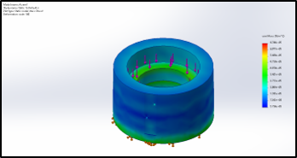
Figure 3.3.1.1: FEA on joint one turret.

Joint 2 – Mica Nellis
The mathematical modeling required for joint two was imperative to the overall success of the design given that the motor supplying movement would need the most torque output and be required to lift the majority of the robot itself. The team originally wanted to purchase a Nema 23 stepper motor with a 100:1 gearbox ratio to ensure the torque requirements could be made, although this motor would not have arrived in time for us to use. To mitigate and resolve this issue a second phase was added along with an addition of a sprocket and chain system to increase the gear ratio, seen below within the figures. The team purchase a Nema 23 with a 50:1 gearbox ratio as added two sprockets one attaching to the motor and the other attached to the joint two spindle. To increase the overall gear ratio the second phase had a gear ratio alone of around 2.25:1 with the larger sprocket having 45 teeth and the smaller one have 18 teeth, thus increasing the overall gear ratio to just over 100:1. Along with this the original motor efficiency seen within the stepper online website had an efficiency of 75% but the addition of the sprocket and chain phase allowed for this efficiency to potentially reach 95.18% using the equation below.
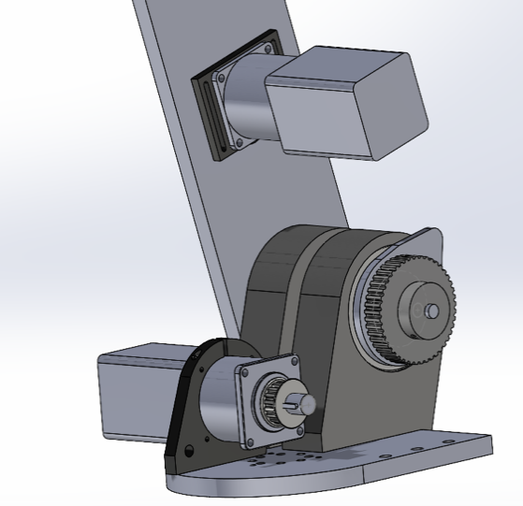
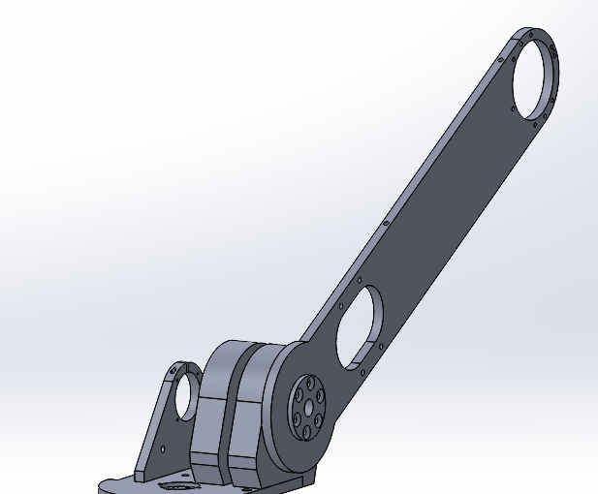
$$EFF \%=1.2 Nm*\left(50*.75\right)*\left(2.25*.94\right)=95.18\%$$

Figure 3.3.2.1: Old Design Figure 3.3.2.2 New design with added phase.

Joint 3 – Russel Stringham
The mathematical modeling for joint three was done through the Finite Element Analysis using SolidWorks. This analysis was done to provide confidence in what materials the parts should be manufactured out of. The areas in question were the key shaft, bearing cup, and spindle. For the key shaft it was found that it should be machined out of steel due to the high amount of torsion applied to it with all the tension from the belt. In addition, machining the key shaft in the lathe allowed for a more of a press fit for the sprocket. For the bearing cup and the spindle, the results of the FEA found that both can be 3D printed out of PLA. The team was very happy with these results because machining both of those parts out of aluminum would have taken a very long time in the lathe and cost way more.
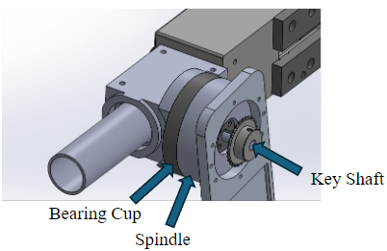
Figure 3.3.3.1: J3 Assembly CAD

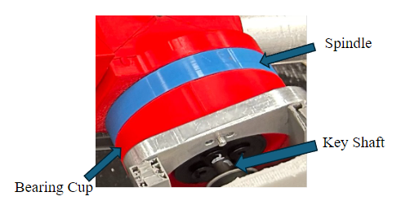
Figure 3.3.3.1: J3 Assembly Manufactured

Joint 4 and 5 – Brandon Knutson
Joint 4 plays a critical role in providing the wrist-like motion necessary for the robot to align its spindle with the plate it is drilling into. The positioning of this joint, being further from the base, imposes significant loads on Joints 2 and 3. To mitigate these loads and optimize the upper structure's weight, an investigation was conducted into the feasibility of utilizing 3D printed parts.

The equation used to assess the weight reduction achieved through material and design optimization is as follows:
Total Weight Savings = Weight Saved from 3D Filament + Weight Saved from Removing Unnecessary Components

SolidWorks was utilized to perform Finite Element Analysis (FEA) testing on the proposed 3D printed upper structure. FEA allowed for the evaluation of structural integrity and deformation under load conditions, providing insights into the design's performance.

Through the implementation of 3D printed parts in the upper structure, a weight reduction of 780 grams (about 1.72 lb) was achieved compared to using aluminum. Additionally, by eliminating an unnecessary joint and motor from the design, an additional 500 grams (about 1.1 lb) of weight savings were realized. This cumulative weight loss of 1.3 kilograms contributes to the overall lightweight design of the robot. Both FEA testing and real-life application demonstrated minimal deflection in the 3D printed upper structure, affirming its suitability for the intended purpose while maintaining structural integrity.
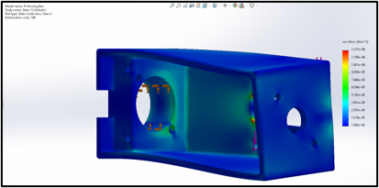
Figure 3.3.4.1: FEA on joint 5 housing.

Torque Calculation – Daniel Cooke
In order to ensure that all of the motors can move their respective joint, the motor must be able to supply more torque than weight of the arm multiplied by the length of the moment arm. The first calculation is the required torque for each joint. The required torque describes the amount of torque required to move the arm, based on the mass of the arm, gravity, and the moment arm to the center of mass. The second calculation is the maximum torque output supplied by each motor. This takes into consideration the standard motor torque output, the gear box reduction ratio, the second stage reduction ratio, and the gear box efficiency. If the maximum torque output outweighs the required torque for each joint, the motors should be able to supply sufficient torque to achieve the desired motion.

Governing Equations and Variables​
Eqn (1): RT = m*L*g​
​
Eqn (2): TMAX= T*GBR*SSR​*eff
​

Required Torque (RT): Amount of torque required to achieve sufficient joint movement (N-m)​
​
Torque Output (TMAX): Peak motor torque output (N-m)​
​
Expected Torque Output (T): Expected torque from each motor (N-m)​
​
Gear Box Ratio (GBR): Gear reduction within the planetary gearbox attached to each motor​
​
Second Stage Reduction (SSR): Additional reduction due to pulleys​
​
Mass (m): mass of the joints that each motor is required to move (kg)​
​
Length (L): Length from the motor shaft to the center of gravity of the joint being moved (m)​
​
Gravity (g): 9.81 m/s^2​
​
Standard Gearbox Efficiency: 85%​
Joint 1​
RT = 25kg*0.5m*2rad/s^2​
RT =25 N-m​​
TMAX = 1.2N-m*10*7.6*.85​
TMAX = 77.52 N-m​​
Joint 2​
RT = 22kg*.5m*9.81m/s^2​
RT = 107.9 N-m​​
TMAX = 1.2N-m*50*2.7*.85​
TMAX = 137.7 N-m​​
Joint 3​
RT = 14kg*.45m*9.81m/s^2​
RT = 61.8 N-m​​
TMAX = 1.2N-m*50*2*.85​
TMAX= 102 N-m​
Joint 4​
RT = 2kg*.01m*9.81m/s^2​
RT = .196 N-m​​
TMAX = 1.2 N-m ​
(not geared)​
In conclusion, the expected torque output from each motor stage outweighs their respective required torque. These calculations exclude factors like slippage about motor shafts, friction losses, and the desired acceleration of each joint during movement. These factors would increase the required torque, however as proved in testing the maximum torque supplied by the motor still outweighs the required torque for each joint.

Electrical – Mason Goodman
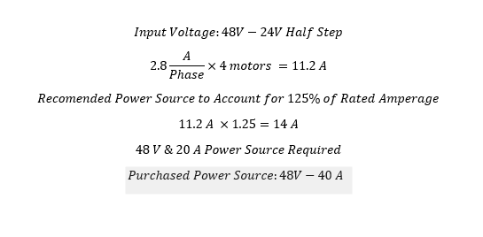
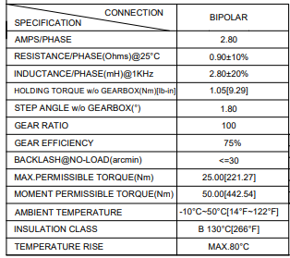
The mathematical modeling for the electrical aspect of the systems was to ensure that the final power supply and motor drivers can deliver proper power to respective joints within the design. This was completed by using specification sheets of the motors the team will be utilizing throughout the design. The robotic arm will use four Nema-23 motors that all have the same base motor, and three motors utilize gearboxes to increase torque output. Below is the specification sheet and the simple mathematics to calculate total power requirements.

The team will utilize a 48-volt and 40-amp power supply that will easily meet the design requirements. Additionally, the team has chosen to use DM542T motor drivers that has 5-amp capabilities, which asks as a safeguard as the rating current for out specific motors are 2.8-amps each. The team had issues with motor driver overheating throughout the prototyping process and took precaution in the final design by having electrical components that can handle much more then out required needs so that safety is ensured.

Design Concepts

Functional Decomposition
Functional decomposition is a systematic process used in systems design and engineering where a complex system or function is broken down into its more manageable and simpler constituent sub-functions. This hierarchical approach divides a system into smaller parts or subsystems, which can then be designed, analyzed, and optimized independently before integrating them into the larger system. By doing so, functional decomposition helps designers and engineers understand the intricacies of the system, facilitates parallel work on different components, and aids in pinpointing potential problems or inefficiencies. Whether applied in software engineering, product design, or systems analysis, functional decomposition ensures that each individual component serves a specific purpose and contributes effectively to the overarching system goal. Figure 4.1 below displays the drill arm’s functional model.
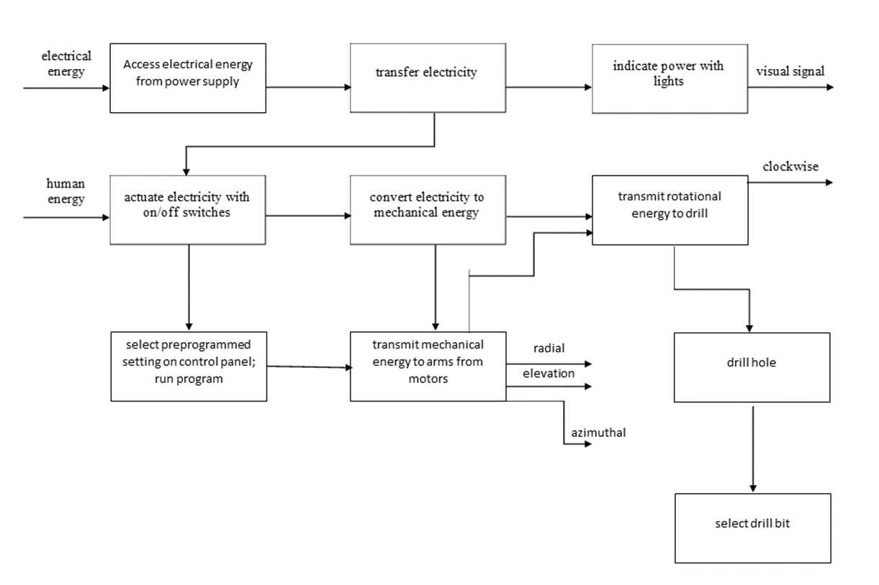

Concept Generation

Initial Process of Overall Drill Arm Concept Generation
The process of designing a robot drill arm involved a series of iterative concept generation phases, each driven by the team’s evolving understanding of the project requirements and the need to strike a balance between complexity, stability, and adaptability. This section outlines the key stages of concept evolution and the valuable insights gained from each iteration.
Initial Concept: Six Degrees of Freedom
The project’s inception saw the exploration of a six-degree-of-freedom robot arm design. The appeal of such a system lies in its high versatility and precision. However, as the team dove deeper into the project, it became evident that this complexity surpassed the needs and budget constraints. This phase served as the introduction to servo motors and cycloidal drives, laying the foundation for overall understanding of advanced robotic systems.
Transition to Scara Robot
In response to the realization that the six-degree-of-freedom design was excessive, the team pivoted towards a Scara robot configuration. This choice, while simpler, posed challenges in terms of stability, deflection, and drilling capacity. The team gained valuable insights into moment arms, friction, and the limitations associated with the reduced degree of freedom. The Scara robot design, though ultimately discarded, served as a learning experience in optimizing the trade-off between simplicity and functionality.
Experimentation with Three Degrees of Freedom
A subsequent iteration involved a three-degree-of-freedom robot arm. While this design provided more stability compared to the Scara configuration, it introduced a new set of challenges. The geometry had to be redesigned for each change in the cylinder, making it impractical for a system requiring adaptability. This phase was instrumental in understanding the importance of adaptable geometry and its implications for drilling capacity.
Four Degrees of Freedom with Spherical Coordinates
After several iterations and the acquisition of a deeper understanding within the field of research,the team settled on a four-degree-of-freedom robot arm design that operates using a spherical coordinate system. This configuration struck a balance between complexity and adaptability. The spherical coordinate system allowed for the required adaptability without the need for constant geometry redesign. Linear actuation and slew drives were employed in this final design, which served as a culmination of the lessons learned from the previous phases.
Final Design: Geometric Robotic Drilling Arm
The final design that the team has created is a geometric, five axis robotic drilling arm. Axis one will be the base axis of the robot allowing for movement left to right. The second axis will move the arm forward and backwards. The third axis will extend off the second axis moving up and down. The final and fourth axis is the end effector location allowing for “wrist” rotation.
In summary, each conceptual iteration in the development of the robot drill arm taught us valuable lessons and expanded the team’s knowledge base. The six-degree-of-freedom robot introduced us to advanced motor and drive technologies, while the Scara design underscored the importance of stability and trade-offs. The three-degree-of-freedom robot emphasized adaptable geometry, the four-degree-of-freedom design proved to be closest to what the team wanted to design although it was much more difficult than what was needed. The final geometric robotic drilling arm incorporated the best aspects of previous concepts, highlighting the importance of iterative design in complex engineering projects.

Electrical Component Wiring
The concept generation for wiring components of the robotic arm is quite simple. Robotic arm designs can implement either internal or external wiring. The most important consideration with both concepts is limiting “loose” or “hanging” wires that can potentially snag on anything whilst the robotic arm performs functions. Given the fact that the arm of the current robotic design will be metal tubing, the team’s expectation is that most of the electrical wiring will be internal. Additionally, the stepper motors included in the design will be located near the base of the robotic arm, therefore wire housing or a simple zip-tie configuration can be utilized to effectively secure the wiring of major components as needed.

Selection Criteria – Top Level
To select the most suitable concepts for the given robotic design, the teamestablished rigorous selection criteria rooted in engineering requirements and project feasibility. Design criteria, encompassing motors, complexity, deflection, and documentation, were meticulously weighted to reflect their relative importance. Motors, while crucial, received a lower weight due to their significant budgetary allocation and pivotal role in system performance. Complexity, on the other hand, was assigned a higher weight, considering the constraints posed by limited time, budget, experience, and tools. Deflection emerged as a critical consideration to ensure precision and repeatability in production assembly, warranting careful evaluation through quantitative analysis. Lastly, documentation was prioritized to leverage existing knowledge and resources, facilitating informed decision-making and troubleshooting. By systematically applying these criteria, and aiming to strike a balance between technical requirements, resource constraints, and project objectives, ultimately guiding the selection of the most viable and robust design solution.
Figure 4.3.1: Decision matrix of top level selection.
 | Motors | Complexity | Deflection | Documentation | Totals
Criteria Weight | 1 | 2 | 3 | 4
6 Degree of Freedom | 1 | 2 | 3 | 3
Rating | 1 | 4 | 9 | 12 | 26
3 Degree of Freedom | 3 | 1 | 1 | 1
Rating | 3 | 2 | 3 | 4 | 12
Scara Robot | 2 | 3 | 2 | 2
Rating | 2 | 6 | 6 | 8 | 22

Concept Selection

Base Rotation
This first concept selection is for the base rotation of the robot. There are two options that the team had to decide what to go with. The first option was slewing drive and the second was a gear system with a spindle. The slewing drive was the simplest option because it was already assembled and just needed a motor to run the system. This was the team originally selected, but they ran into many issues with finding a supplier to purchase from. In addition, the cost of the slewing drive was super expensive and left less of the budget for other parts. The gear system and spindle were a way cheaper option and the material, and parts needed for this system were faster shipping. The design was more complex due to having more parts and parts that needed to be manufactured. In addition, this system gave less power but after some calculations done with weight of the system the gear system would still work fine. Therefore, as shown in the decision matrix below the team decided to go with the gear system and spindle.

Table 4.4.1.1: Base Rotation Decision Matrix
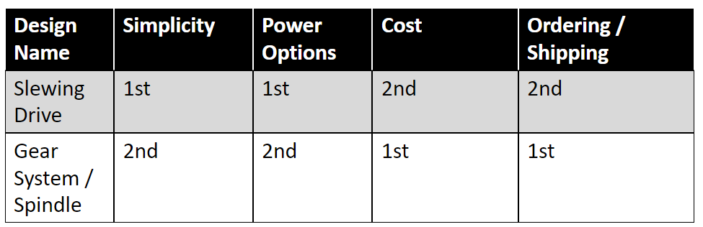

Gear System for Joint 2 and 3
The next concept selection done by the team was for the gear system for joint two and joint three. The concepts were a belt and pulley system and a chain and sprocket system. The belt and pulley system were the original choice by the team due to the familiarity and simplicity of the system. After purchasing and assembling the belt and pulley system the team found that it did not provide enough of a torque output and was difficult to tension. These issues cause the motors to not move the arm properly. The team then had to decide whether to continue with a belt and pulley system or switch to a chain and sprocket system. After performing torque calculations, the team found that the chain and sprocket was the best option. The torque that the new system provided was plenty for all the arms to move properly. The decision matrix below shows the breakdown of the two concepts.

Table 4.4.2.1: Gear System J2/3 Decision Matrix
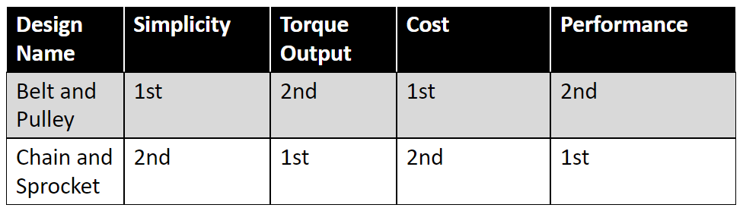

Wiring Selection
The wiring selection process utilized a decision matrix to decern the best selection for high-flex component wiring of the robotic arm. The criteria developed in section 4.3.5 were weighted and based on the specifications in Table 5.8 were ranked on a scale of one to five. The weighted total was then calculated, and the results are shown below in Table 4.8.

Table 4.4.3.1 Wiring Decision Matrix
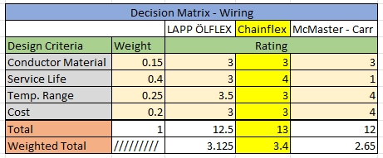

Preliminary design expectation was to utilize linear actuators in unison with the end effector to create the robotic arm movement the customer needs required. Therefore, the end-effector, linear actuators, and motors required to run the components were identified as “high-flex” components in which the included wiring would need to be adjusted to account for the continuous wear the cheaper wiring would experience. However, team design iteration has simplified the design to utilize a pully or chain system along with motors positioned at the base to accomplish robotic arm movement. Therefore, the only component that has been identified as “high flex” in the current design is the end-effector. Overall, this simplifies the electrical wiring components of the robotic arm design.

Schedule and Budget

Schedule
Figure 5.1.1 below displays the Gantt chart for this first semester’s work efforts. The first phase of the project, outlined in blue, saw the team completing relatively simple tasks such as initial research, breaking up into sub teams, creating the tasking for the team itself, and completing the team charter. Once these were completed, the team moved onto more complex tasks such as the quality function deployment (QFD, where the team decided how to transform the client’s requirements into engineering requirements as well as prioritizing which ones needed to have a higher importance than others), the Gantt chart (where all of these tasks were listed and described alongside their respective due dates, timelines, and completion statuses), parts and literature research (an further round of research into parts and any literature which may be of interest to the team), budget planning (where the team decided how to best apply the given funds to the project), and the first presentation (where the team presented its initial efforts in research and simple calculations that were performed). Staff meetings and peer evaluations, where the team came together to discuss updates, next steps, and any changes that needed to be made to each member’s respective end of the project, as well as provide feedback for one another at periodic points throughout the semester. Client meetings also occurred biweekly with our client to provide updates on the project on whatever work the team had completed within each set of two weeks. It should be noted that staff meetings, peer evaluations, and client meetings were regularly repeated with little change in how each of these tasks worked, so further reporting on each of these tasks will be omitted in following descriptions of each phase of the project.
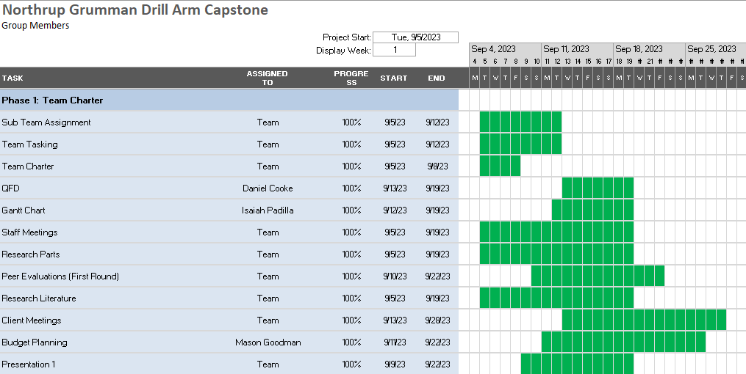
Figure 5.1.1: First Phase of the Project

Figure 5.1.2, shown below, displays the second phase of the project, as highlighted in red. This second phase saw the team starting the initial set of Computer Aided Design (CAD) work on a prototype, order the first set of parts for a prototype, and design a website to be updated throughout the semester for the team containing multiple pages including a home page, about us section, documentation, gallery, team listing, and project description, as well as a page with information on how to contact members of the team. A client presentation was conducted, though due to client time constraints, it wouldn’t be presented until close to the end of the third phase of the project. This presentation gave the clients a complete update on what the team was doing to solve their problem, as well as showing them all the progress that was made, what considerations are being taken, and how risks are being mitigated. Parts research continued and ended late in the phase cycle, with prototype parts being ordered alongside the end of that research such that the team could construct its first prototype. The first team report was created, containing a total summary of every single piece of work completed by the team up to that point in time, including a project summary and description, calculations, literature review, schedule, CAD work, Bill of Materials, QFD, functional diagram, black box diagram, budget updates, and any other relevant information. The analytical analysis memo was dedicated to helping team members come up with their own ideas on how to conduct separate sets of calculations to be performed such that they could mathematically prove other parts of the current design, to be completed in a later assignment. The second presentation was essentially an update to the first, providing all updated information and efforts in the project, alongside any new calculations and literature review efforts.
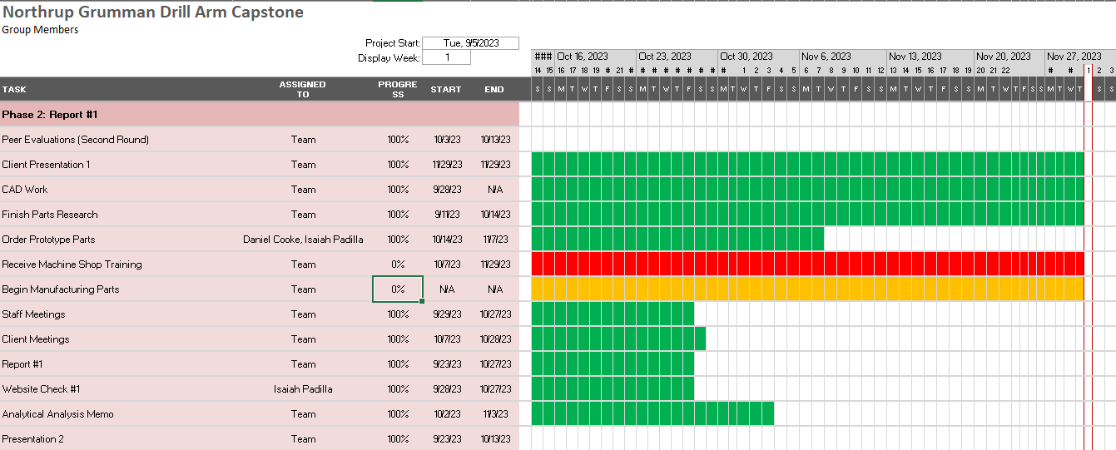
Figure 5.1.2: Second Phase of the Project
Figure 5.1.3, shown below, displays the third and final phase of the first semester’s work effort. The first prototype built by the manufacturing sub team was presented in class to display a working robotic arm. The bill of materials and final CAD efforts were also completed together for the final prototype, which was also designed to be scalable so the team could use it for the final product. The final prototype assembly and demo, which aren’t complete at the time of writing but soon will be, will be presented in class to fellow teams for constructive feedback. The project management assignment will act as a review for both this semester and an outline for how the team can set itself up for success next semester. A second website check will be performed to see how the team’s website is coming along. This will provide an opportunity to see whether the website has sufficient material on it and looks presentable. A second team report was also completed involving further updates and calculations, additional literature review elements and the final CAD and Bill of Materials efforts.
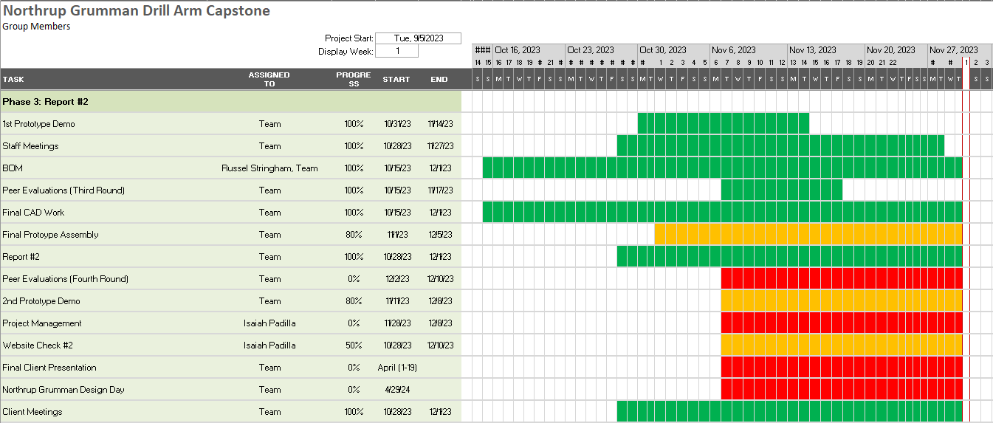
Figure 5.1.3: Third Phase of the Project

Figures 5.1.4-5.1.6 below shows the entire second semester, outlining the work to be performed during the second semester. This fourth phase, highlighted in orange, shows the basic taskings for the last semester, including the staff and client meetings and the peer evaluations. However, much of the work involved both getting the team certified to use machine shop tools to manufacture parts based on the CAD work performed by the team as well as the actual manufacturing of each joint. A final product demonstration will be completed both in class and during the client’s presentation day (Northrop Grumman’s Design Day, in this case). Three hardware status updates were performed for the class, though the second was swapped out for a critical design review presentation given to the client. Testing efforts must be conducted after the product assembly is completed. An individual self-learning assignment will also be given to the team at some point, though it is unknown what the focus will be. Any revisions to the CAD package assembled by the team were made throughout the semester. Once assembled, testing of the product was conducted as well. The final report alongside the corresponding poster was assembled and created for use on the client’s presentation day. Two more website checks were conducted to ensure the website's development is going well. A specification sheet, operation, and assembly manual will need to be assembled by the team for the client to be able to use on their own, which will be given to the client during the handoff following the final presentation.
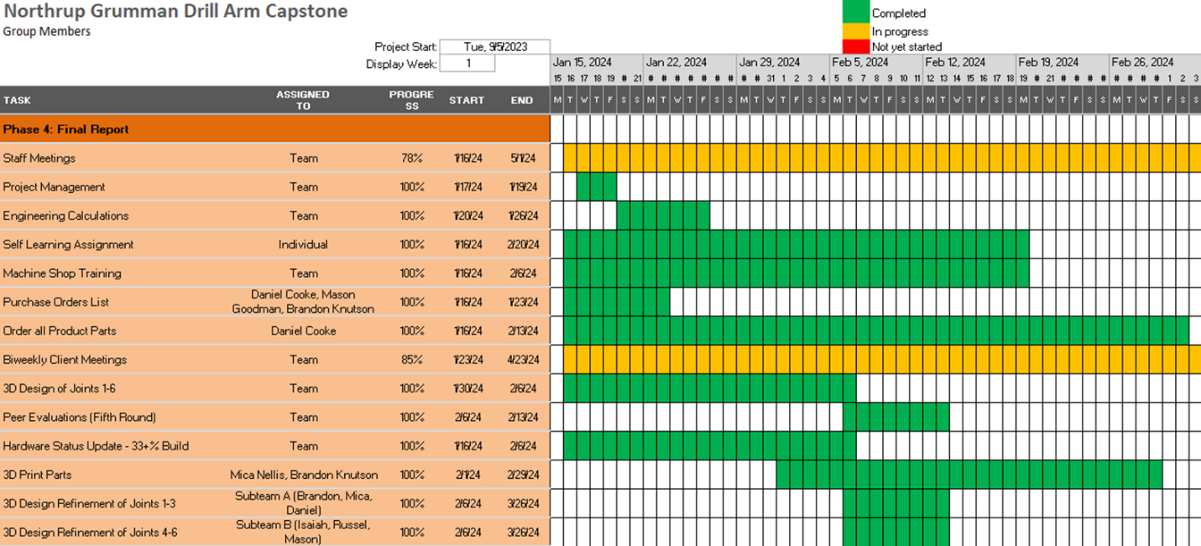Figure 5.1.4: Fourth Phase of the Project (1/3)

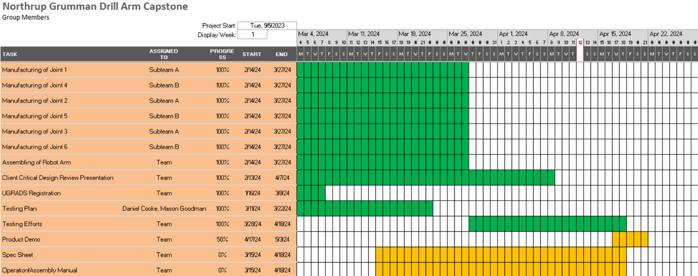Figure 5.1.5: Final Phase of the Project (2/3)

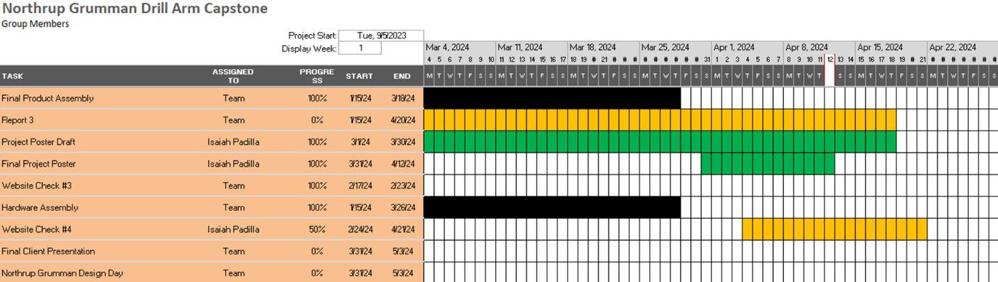Figure 5.1.6: Final Phase of the Project (Part 3/3)

Budget
The budget for the entire project can be broken down into two major categories: final product budget and the testing and prototyping. Each category can be broken into subcategories based on what parts fall into that subcategory: raw materials, motors and drivers, electrical components etc. All numbers were gathered from the manufacturing and purchasing bill of materials. The Final Product Budget can be found below in Table 5.2.1 and the Testing and Prototype Budget can be found in Table 5.2.2.

Table 5.2.1: Final Product Budget
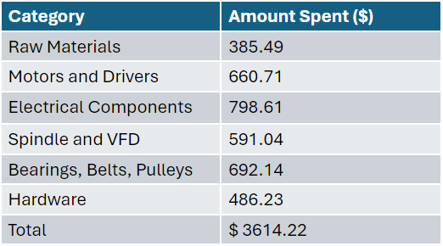

Table 5.2.2: Testing and Prototype Budget
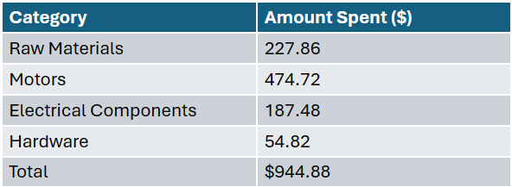

Bill of Materials (BoM)
The following tables include brief sections of the bill of materials for both purchased and manufactured parts used in the final construction of the product. The complete Bill of Materials can be found in Section 12.2 Appendix B: Purchasing and Manufactured Bill of Materials.
Table 5.3.1: Manufactured Bill of Materials
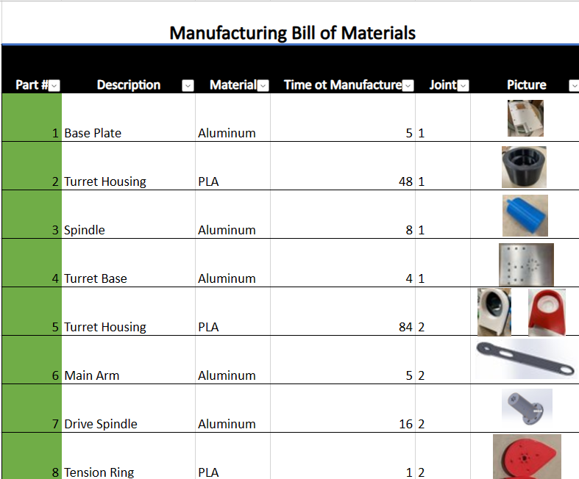

Table 5.3.2: Purchased Bill of Materials
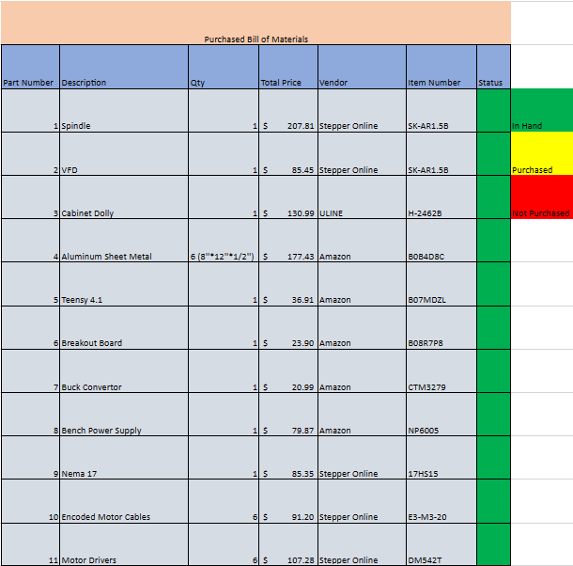

The total number of parts to be manufactured was 30 with a total manufacturing time of 407.2 hours. There was a total of 68 parts purchased for construction of the final product. The total cost of these parts, not including raw materials, was 3975.99 dollars.

Design Validation and Initial Prototyping

Failure Modes and Effects Analysis (FMEA)
The failure mode and effects analysis (FMEA) is used as a preventative measure to anticipate problems that may arise in the manufacturing, assembly, and testing phases. Each failure mode is ranked on a scale of one to ten based on the failure’s severance, occurrence, and detection capabilities. These scores are combined to determine the failure’s risk priority number (RPN). A higher RPN associated with potential failure means that failure is more likely to occur and should be addresses immediately. An FMEA was conducted on each joint, individual motor stages, and the electrical components. The analysis at each joint was consistent in determining that the most important failure modes to address were loss of tension in the timing belts, as well as deflection of the motor mounts. Both failures could potentially result in the complete loss of an individual joint. Therefore, mitigation plans were implemented to prevent the occurrence of these failures. Two out of the three timing belts were replaced with chain and sprocket systems that decrease the likelihood that the belt will slip and lose tension due to excessive torque. The motor mounts for joints one through three were redesigned to be manufactured from aluminum, which increases motor stability and decreases the risk that the motor mount would deform under high stress. The FMEA for the electrical components and individual motor stages can be found below in Tables x and x. All other FMEA tables can be found in Appendix x.

Table 6.1.1: FMEA for Electrical Components
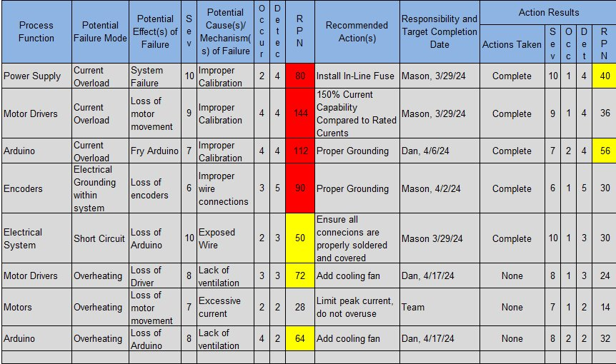

Table 6.1.2: FMEA for Individual Motor Stages
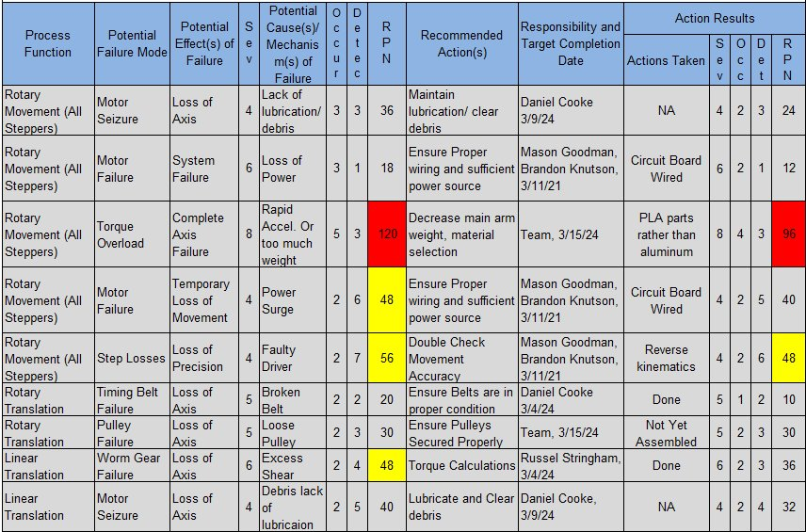

It can be seen in the FMEA table for electrical components that the main points of concern are excessive current from the power supply, overheating, and unstable wire connections. The installation of an inline fuse would prevent any current overload to the motor drivers; however, it is still a point of concern. To prevent overheating of the motor drivers and Arduino, a 12-volt fan was installed to increase convective cooling. The wiring layout and terminal connections were checked and validated by Professor Willy prior to turning on the power source. This would have prevented any potential short-circuits or grounding issues that could have fried the motor drivers or Arduino.
The second FMEA table addresses potential failures of all motor stages. The main concern for each motor it was either insufficient or excessive torque provided to the motor’s respective joint. Too little torque would result in the joint not being able to move, and too much torque could result in an axis failure due to lashing. This problem was mitigated through torque and weight calculations, as well as programming the adequate joint speed and acceleration within the Arduino IDE software.

Initial Prototyping

Design Prototype 1
Design Prototype 1, shown below in Figure 6.2.1.1, displays the original prototype created by the team. This prototype sought to answer whether a robotic drill arm can be constructed without becoming a 6 DOF arm. It was discovered that this prototype made the overall implementation of the design more challenging and limited the team in terms of options and design freedom. As a result, the team made complete redesigns which were meant to improve rotation capability and the strength of the lateral drill action.
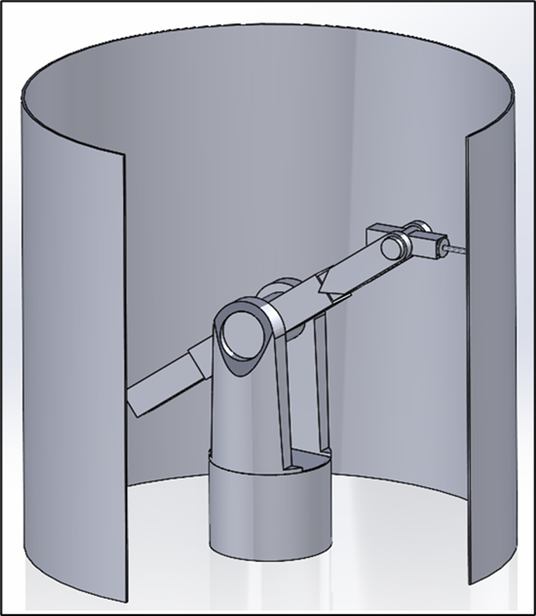
Figure 6.2.1.1: Design Prototype 1

Design Prototype 2
Design Prototype 2, shown below in Figure 6.2.2.1, details the second design prototype created by the team. This prototype sought to answer whether a robotic drill arm can be constructed through only a few degrees of freedom. Although this design iteration would eventually make it to being a scaled mini model as seen in Figure 6.2.2.2 below, it was determined that the design did improve simplicity of the design and helped make the calculations less complicated. This design iteration was fully implemented into a working prototype but also ultimately was forgone for a better design eventually. This effort helped inform future design efforts on how the team should seek out better DOF capability as well as what to look for to solve the continuing issue of rotation capability.

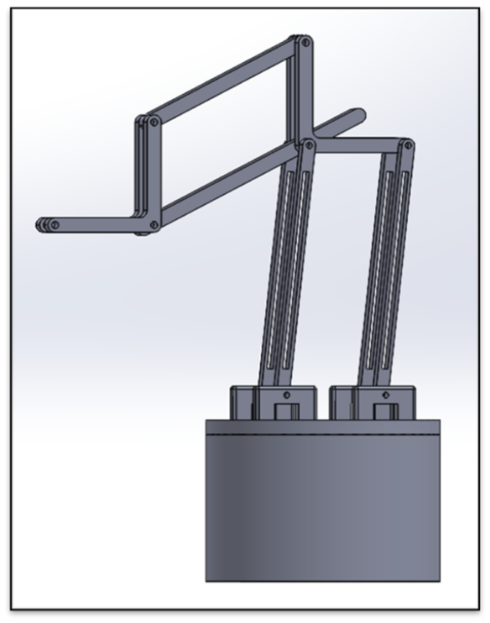
Figure 6.2.2.1: Design Prototype 2
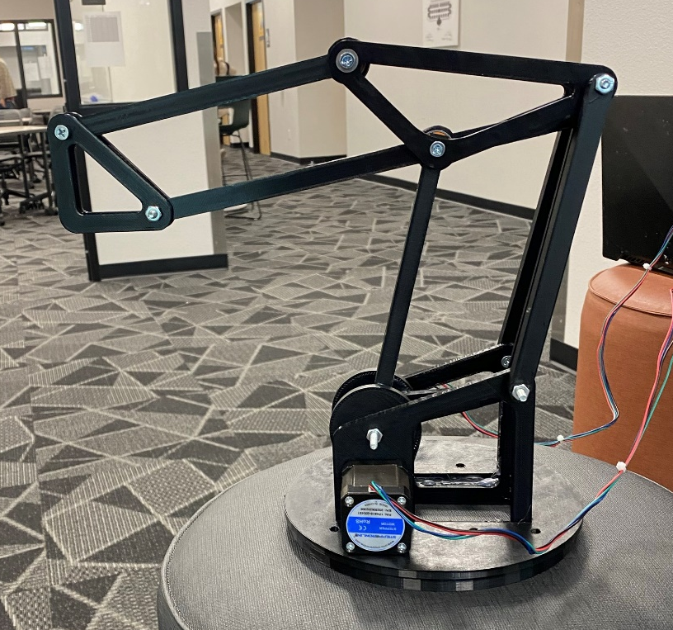
Figure 6.2.2.2: Physical Prototype

Design Prototype 3
This final design iteration before the team’s final design was put in place is displayed below in Figure 6.2.3.1. The objective of this design was to answer the question of whether a robotic drill arm could be constructed with the use of multiple pulley systems to improve efficiency. The result was that this design effort culminated in a design which worked but presented many issues with the base rotation, requiring an extremely expensive part to move. Once more, it was decided to redesign completely after this design iteration. This design iteration never made it to a physical prototyping stage. Future design sought to improve on maneuverability and rotation capability.

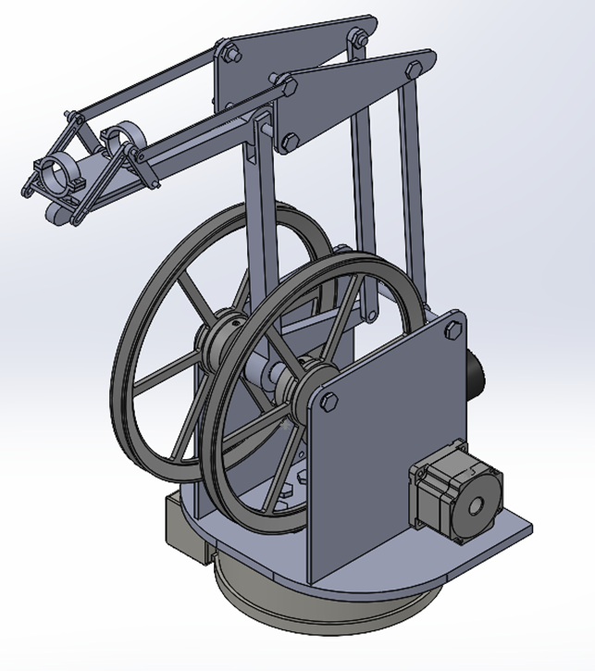
Figure 6.2.3.1: Design Prototype 3

Future Testing Potential
Future testing and design the team has identified and discussed are composite drilling material congruent with Northrop Grumman manufacturing, improved spindle design, reduction of 3-D printed parts on the design itself, and a transition to chain and sprocket usage for all motor movement. Northrop Grumman manufactures a variety of materials for systems in which they send into orbit. To ensure that the team design is compatible with all manufacturing materials, the team foresees the testing of multiple drilling materials to guarantee manufacturing compatibility. In conjunction with additional material testing, the future need for an end-effector that can handle tougher material properties will be a necessity of the design. Therefore, the team will want to reevaluate torque requirements of individual joints as a spindle with more capability will inevitably carry more weight. In the current design, the team uses two chain and sprocket assemblies and a single belt-pulley assembly. The team found that the performance of chain and sprocket assemblies for high-torque application far exceeds that of the belt-pulley system. Therefore, in the future the team will convert all motor assemblies to a chain and sprocket system for increased rigidity and performance. Lastly, in order to reduce costs throughout the robot the team utilized Polylactic Acid (“PLA”) filament for a variety of parts. In higher stress drilling operations this poses potential problems. To increase overall structure strength, the team would like to transition to a design that feature all aluminum parts, and the use of steel in higher stress parts. These future design tests and changes will increase robotic performance and legitimize the design as a whole for all manufacturing processes.

Final Hardware

Final Physical Design

Final Assembly – Russel Stringham
This is the final assembly that was chosen by the group for manufacturing. As shown in the image below there are five joints, degrees of freedom, for the robot. This assembly is mounted to a dolly cart to allow for the assembly to move around. The full assembly weighs approximately 110 pounds and includes 55 individual parts. These parts are a combination of machined parts and purchased parts. The machined parts were made of PLA, aluminum, and steel. The details for each joint are listed below in the sub-assemblies.
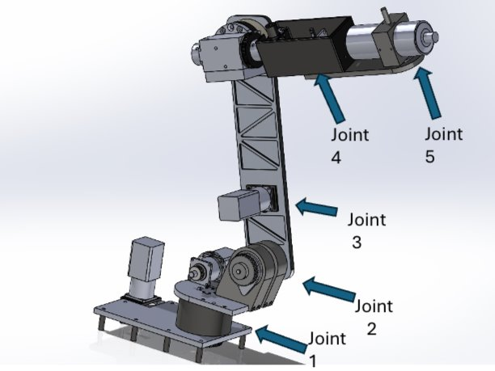
Figure 7.7.1.1: Final Assembly CAD
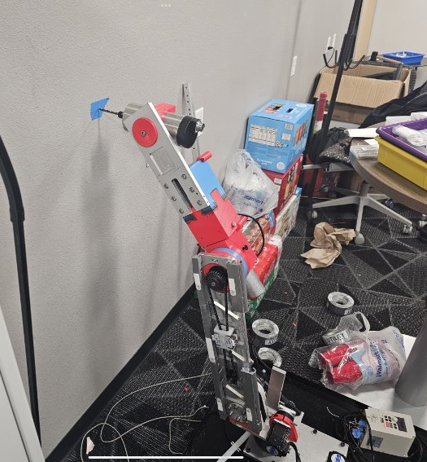
Figure 7.1.1.2: Final Assembly Manufactured

Joint 1 – Brandon Knutson
Joint 1, serving as the foundational element for the robot's base rotation, is meticulously designed to withstand operational demands while ensuring precision and stability. The physical configuration comprises a combination of carefully selected materials and components, tailored to fulfill the functional requirements of the joint. The core component of Joint 1 is the 3D printed base, strategically engineered to provide structural support and stability. This base serves as the primary platform upon which the entire rotational mechanism is built. Its design is optimized for strength and rigidity, ensuring reliable performance under various loading conditions.
Bound within the 3D printed base are two large, tapered roller bearings, meticulously chosen for their ability to handle radial and axial loads with exceptional durability. These bearings facilitate smooth rotation of the aluminum spindle, enhancing the overall efficiency and longevity of the joint. The aluminum spindle, a key structural element of Joint 1, serves as the central axis around which the rotation occurs. Its robust construction ensures stability and precision, crucial for accurate alignment of the robot's components during operation. At the bottom of the spindle, a large gear is securely attached, providing the necessary torque transmission for rotational movement.
The gear mechanism is further enhanced by gearing to the motor, optimizing power transfer efficiency, and facilitating controlled motion. This arrangement ensures synchronized operation and precise control over the rotational movement of Joint 1. Integration with the rest of the robotic system is achieved through the attachment of the spindle's top part to the turret plate of Joint 2. This connection establishes a seamless link between adjacent joints, enabling coordinated motion and precise positioning of the robot's end effector.
Additionally, a dedicated base plate for Joint 1 provides a stable foundation for mounting both the turret base and the motor with an adjustable motor mount. This configuration enhances versatility and ease of assembly, allowing for precise alignment and adjustment of components to meet specific operational requirements.
In summary, the physical design of Joint 1 embodies a careful balance of structural integrity, precision engineering, and functional integration. Through the strategic selection of materials, components, and configurations, Joint 1 is engineered to deliver optimal performance, reliability, and efficiency within the robotic system.
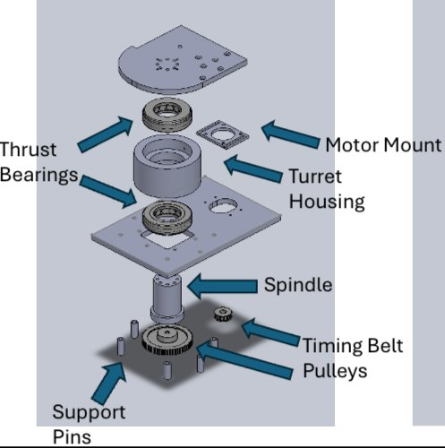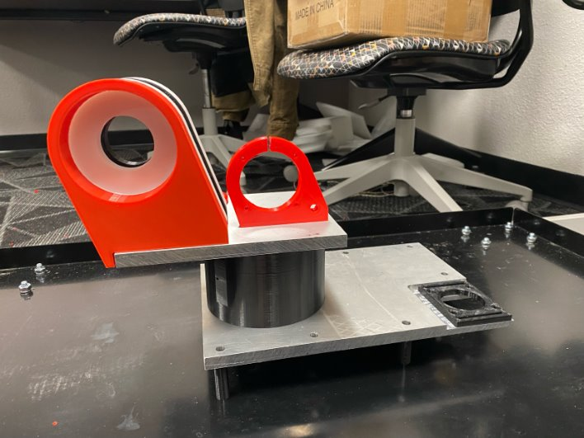
Figure 7.1.3.1: Exploded CAD view as well as physical assembly of joint 1.

Joint 2 – Mica Nellis
The joint two subassembly is used for the arm motion of the robot allowing for reaching in the horizontal direction, as well as allowing for force to push the end effector through the dished composite material. Using a Nema 23 motor located behind the arm itself with a chain and sprocket system allowing the motor to push and pull the arm in the desired direction. Near the bottom of the arm there is a spindly that extends through the arm itself, the turret housings, and bearing thus allowing for movement of the whole system. The mentioned turret housings are simply a guide for the spindle as well as what allows joint two’s connection to joint one. A breakdown of the components of joint two can be seen below.
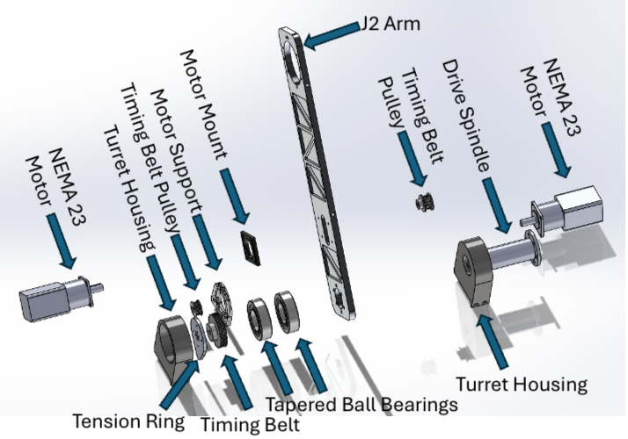
Figure 7.1.3.1: Exploded view of Joint 2.

Joint 3 – Russel Stringham
This sub-assembly of the robotic arm is joint three. The purpose of joint three is to move the second arm where joint four, joint five, and the end defector are located. The pivot point of joint three is off the top of two arm. The system runs on a NEMA 23 motor located low of the joint two arm. There is a sprocket attached to the motor and a chain runs up to the larger sprocket, indicated in the image below. The bearing cup is attached to the J2 arm and is the only stationary piece of the assembly. All the other parts move when the motor is spinning. The bearings in the assembly are essential for great rotation of the arm and putting less strain on the motor. Everything that was machined in this assembly was 3D printed except the key shaft which was made from steel. All parts need to be assembled tightly to allow for the rest of the arm to be as straight as possible.
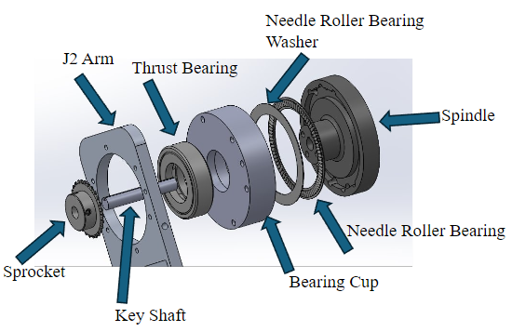
Figure 7.1.4.1: J3 CAD Assembly

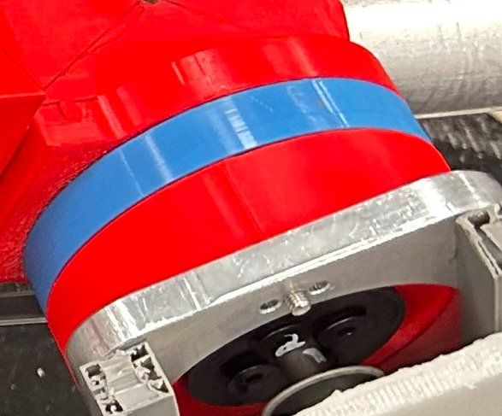
Figure 7.1.4.2: J3 Manufactured Assembly

Joints 4 and 5 – Brandon Knutson
Joint 4, positioned as the final joint of motion before the spindle, plays a critical role in enabling precise alignment of the robot's end effector with the surface of the plate it is drilling into. Designed to function as the robot's wrist, Joint 4 incorporates a sophisticated mechanism to facilitate controlled motion and ensure accurate positioning. At the heart of Joint 4's motion is a linear actuator motor equipped with a trapezoidal screw rod. This motorized system enables linear movement of a shuttle along the axis of the screw rod, translating rotational motion into linear displacement. The use of a trapezoidal screw rod ensures efficient power transmission and precise control over the movement of the shuttle.
Attached to the shuttle is a belt, serving as the intermediary mechanism for transmitting motion to the rotational components of Joint 4. This belt is wrapped around two pulleys, one of which is connected to the spindle while the other rotates freely. The rotational motion of the spindle is thus synchronized with the linear movement of the shuttle, enabling coordinated wrist-like motion of the robot. The design of Joint 4's motion mechanism is carefully engineered to achieve optimal performance and reliability. By harnessing the linear actuator motor's capabilities and integrating it with a belt-pulley system, Joint 4 ensures smooth and accurate motion control, essential for achieving precise alignment during drilling operations.
Furthermore, the utilization of a belt-pulley configuration offers flexibility and ease of maintenance, allowing for simple adjustments and replacements when necessary. The freely rotating pulley serves to minimize friction and ensure smooth operation, enhancing the overall efficiency and longevity of Joint 4.
In summary, the physical design of Joint 4 embodies a synergy of mechanical components and motion control systems, meticulously engineered to fulfill the specific functional requirements of the robot's wrist-like motion. Through the integration of linear actuator technology and belt-pulley mechanisms, Joint 4 enables precise alignment and positioning, thereby enhancing the overall performance and capabilities of the robotic system.

Electrical
The final electrical hardware features a 48–volt and 40–amp power supply that ensures the motor and control components will run smoothly in the design. The team included a 40–amp in-line to protect the power supply in case of an amperage surge. The power supply itself will power four motor-drivers that have 5-amp capabilities as well as 4-amp in line fuses for the case of amperage surge based on load. A teensy 4.1 microcontroller was selected for motor control, and magnetic encoders as well as limit switches will be used for more precise movement. Overall, the electrical design components ensure that the robotic arm will move and function as expected. Figure 7.1.6.1 and 7.1.6.2 are the electrical diagram and a physical representation of the hardware respectively.
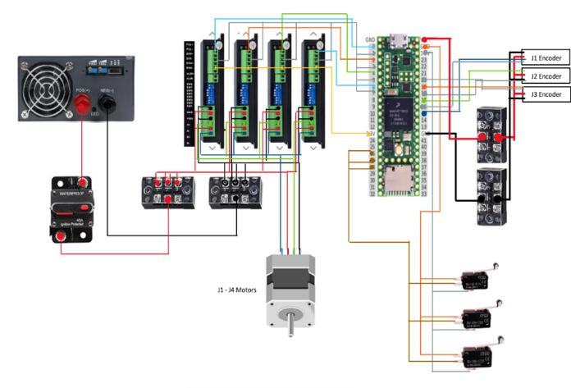
Figure 7.6.1.1: Electrical Diagram

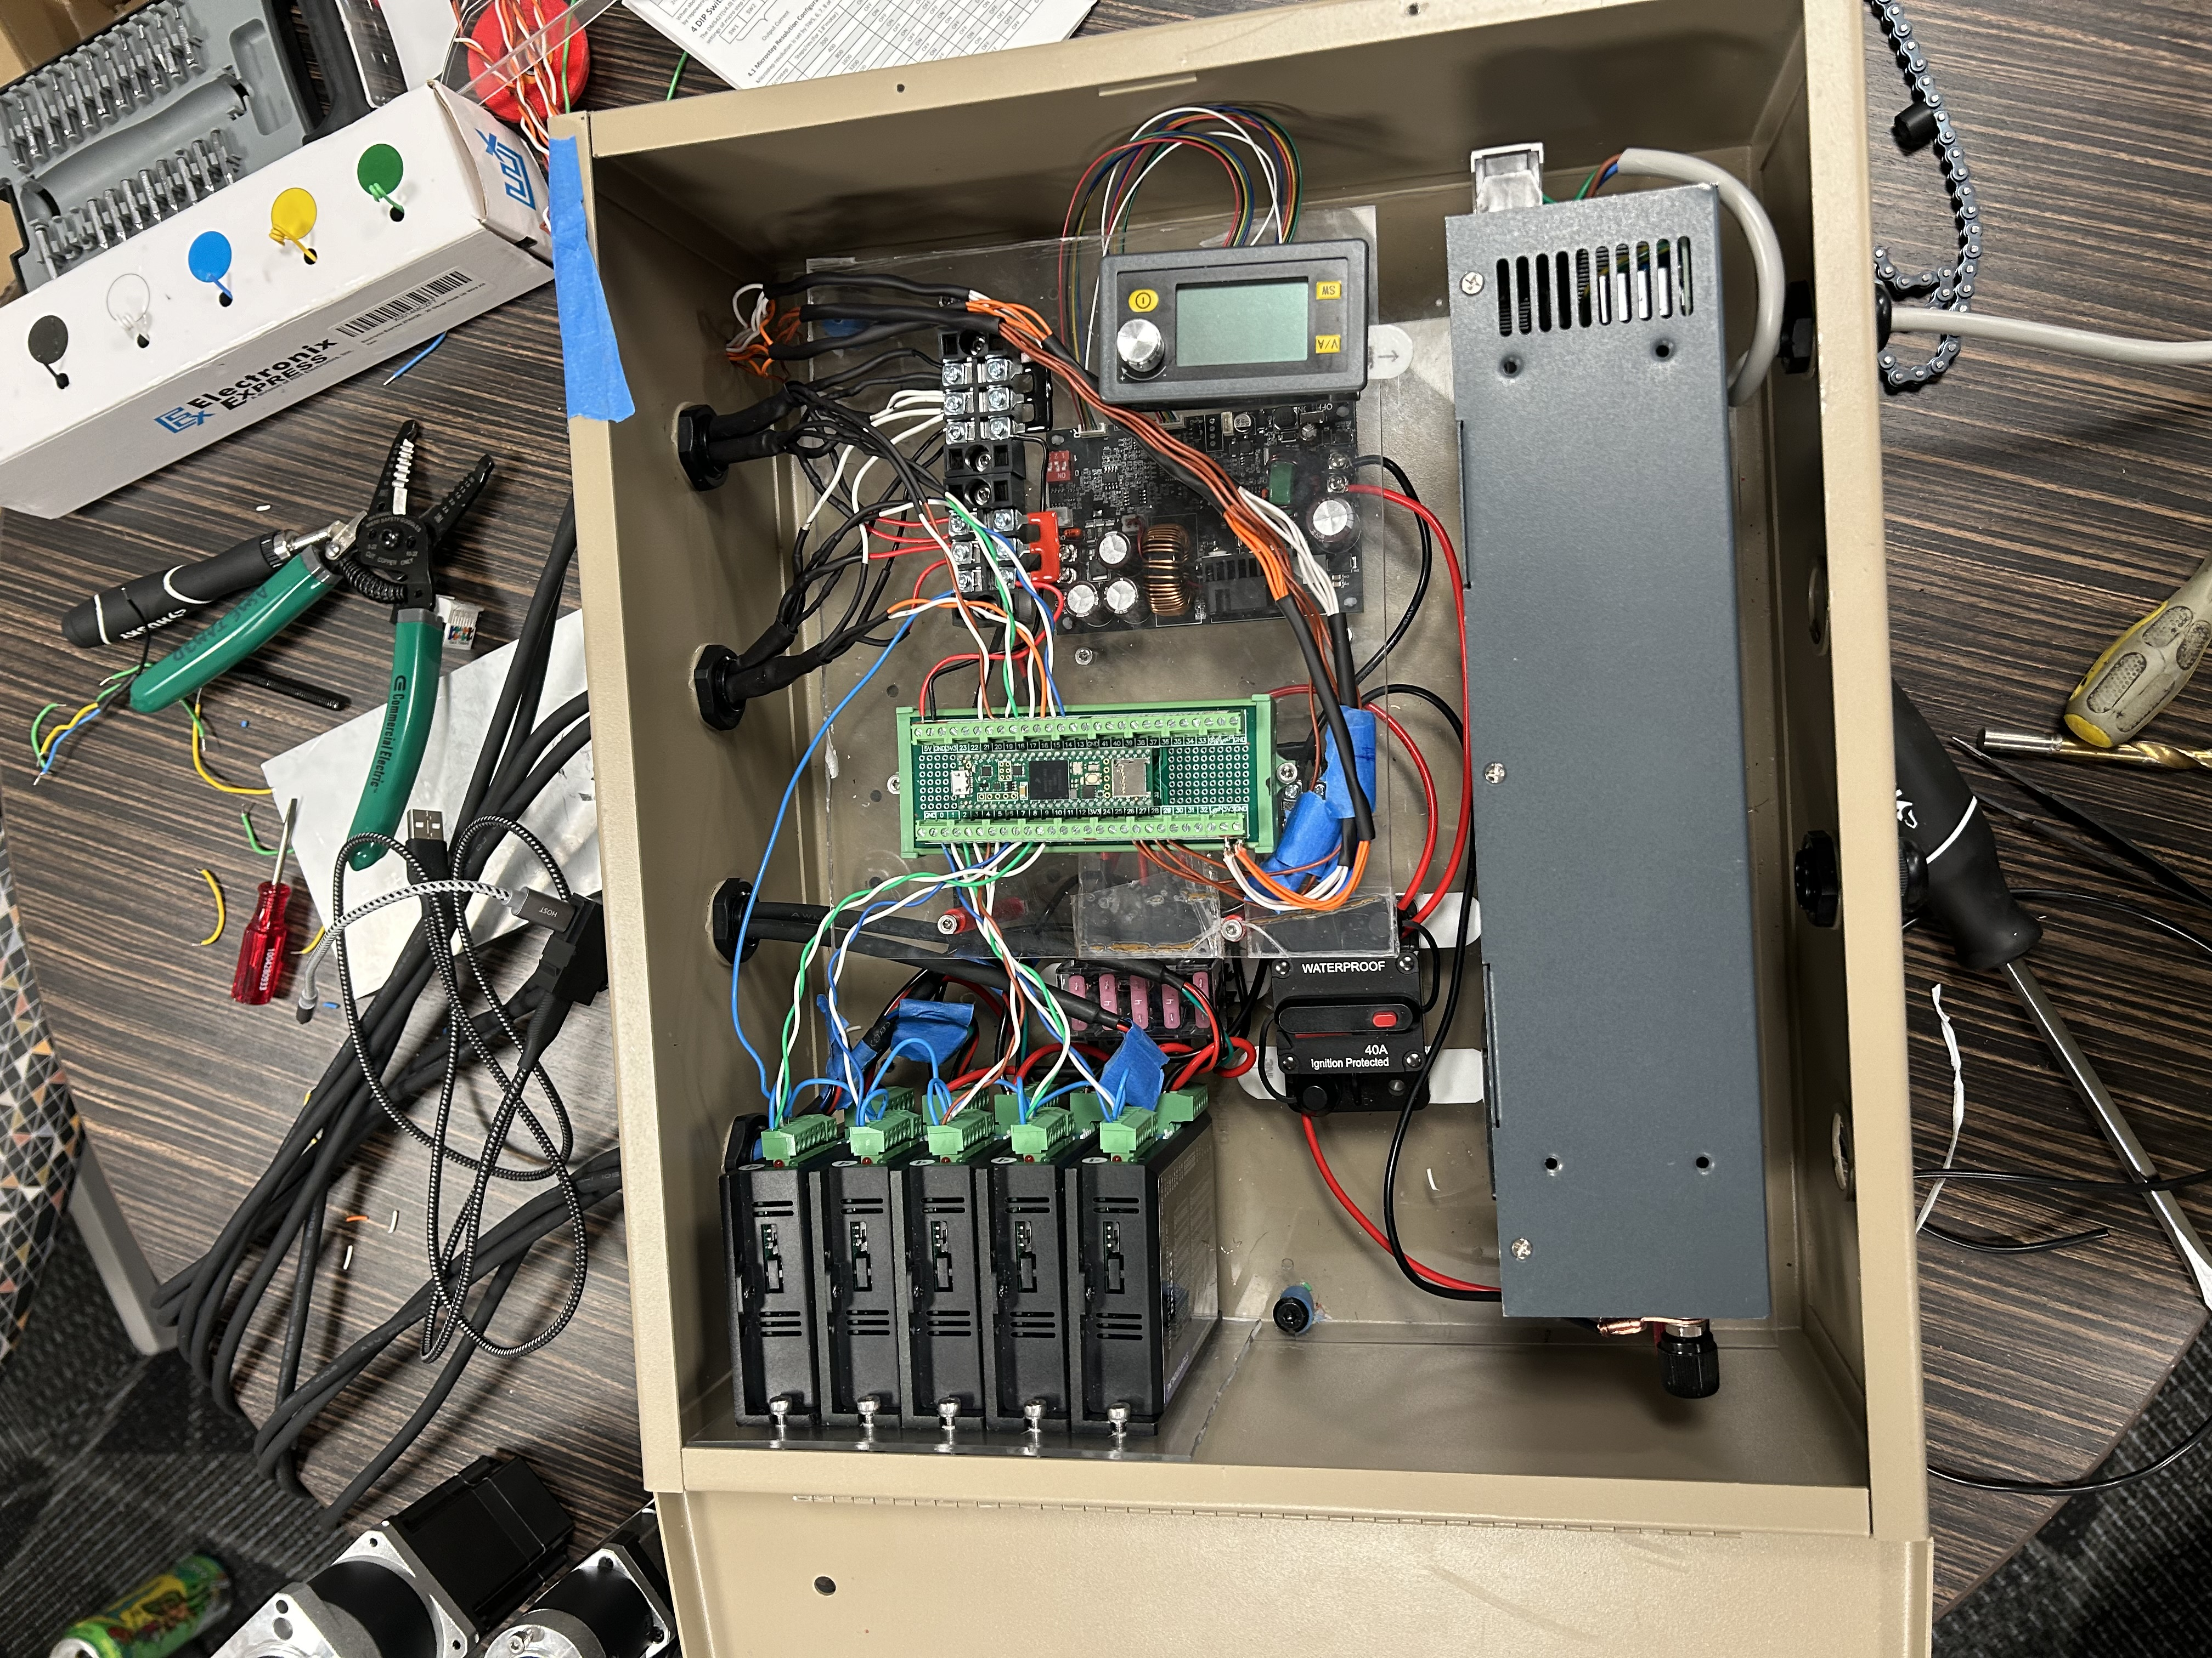
Figure 7.1.6.2: Physical Representation

Final Testing

Top level testing summary table
Throughout the testing process the team had four necessary tests that were to be completed. The first test is two test the motor amperage of all motors within the assembly. This was completed by providing varied loads on the two different types of motors within the system. The second test was to compare the spindle speed to the VFD power supply. This test was to confirm that with the desired amount of power, in Hertz (Hz), would allow the spindly to rotate at an acceptable speed to ensure the drilling operation could be completed. The final two test relied on each other heavily being refined joint displacement as well as real world simulation. The refined joint displacement test was to confirm that all joints within the system would behave properly in the X, Y, and Z. As mentioned, this directly impacts the real-world simulation test given that the team intended move in multiple planes and complete the drilling operation. Seen in Appendix A is a table broken down for all mentioned tests completed throughout the design process.

Detailed Testing Plan

Torque Speed Curves

Summary
Within testing of the Nema Motor acquired from Stepper Online, equipped with an integrated gearbox, aiming to elucidate its torque-speed characteristics. The integrated gearbox promised enhanced torque output at reduced speeds, catering to applications demanding high torque in constrained spatial environments. The methodology involved the construction of a pulley system, affixed with a cable and weights, to gauge the motor's ability to lift loads at various speeds.

Procedure
To construct the torque-speed curve, we systematically varied the motor's RPM settings while adjusting the weights attached to the pulley until the motor reached its operational limit, unable to lift the load at the specified speed. This iterative process allowed us to capture the motor's torque output across a range of rotational speeds, facilitating the development of a comprehensive torque-speed profile.

Results
Upon analysis, the generated torque-speed curve exhibited a close resemblance to the specifications provided by Stepper Online. However, notable discrepancies emerged in the torque values obtained for equivalent speeds. Recorded torque values consistently exceeded those provided by Stepper Online, indicating a potential discrepancy between theoretical and practical performance.
Furthermore, experimentation revealed intriguing insights into the influence of the integrated gearbox on motor performance. Without the gearbox, the motor experienced a significant decline in power output, particularly at lower speeds. Conversely, the torque output remained relatively consistent for extended durations when the gearbox was engaged, underscoring its efficacy in amplifying torque while mitigating power losses.
Overall, torque-speed analysis of the Nema Motor with an integrated gearbox unveiled nuances in its performance characteristics. While the outputted experimental data closely aligned with the manufacturer's specifications, discrepancies in torque values warrant further investigation into factors influencing motor performance. Moreover, the pivotal role of the integrated gearbox in sustaining torque output merits attention, highlighting its importance in applications necessitating high torque at reduced speeds.
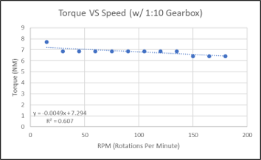 | 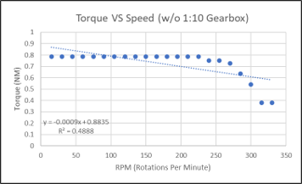 | 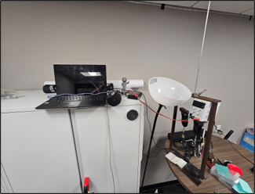
Figure 8.2.2.1: Torque speed curves with and without gearbox as well as testing set up.

Power and Efficiency

Summary
To better asses of the Nema Motor obtained from Stepper Online, featuring an integrated gearbox, we examine the power characteristics and efficiency of the system. Understanding the power input-output relationship and assessing the efficiency of the gearbox were paramount to evaluating its practical performance relative to manufacturer specifications.

Procedure
To determine the power and efficiency of the motor-gearbox system, we conducted experiments using a pulley system equipped with weights. By adjusting the speed settings of the motor driver, we identified the maximum weight the system could lift at each speed, thereby discerning the motor's power output across different operational conditions. Concurrently, data on power input into the system were collected using a variable power supply, enabling a comprehensive assessment of input and output power.
Furthermore, we conducted comparative experiments without the gearbox to isolate its influence on system performance. This allowed for the determination of gearbox efficiency by juxtaposing the theoretical and practical power outputs of the motor with and without the gearbox engaged. Stepper Online's claimed gearbox efficiency of 85% served as a benchmark against which the experimental findings were evaluated.

Results
Our analysis revealed intriguing insights into the power dynamics and efficiency of the motor-gearbox system. By comparing input and output power values, we calculated the system's efficiency, quantifying the extent to which power was effectively transferred from input to output. Remarkably, experimental determination of gearbox efficiency yielded a value of 87%, surpassing Stepper Online's stated efficiency.
This discrepancy may be attributed to various factors, including manufacturing tolerances, environmental conditions, and measurement inaccuracies. Notably, the calculation of the average torque for the motor with the gearbox (6.82 Nm) compared to the motor without the gearbox (0.7871 Nm) provided key insights into the gearbox's amplification effect. Assuming a gearbox ratio of 1:10, the theoretical power output of the motor with the gearbox was estimated at 7.871 Nm, forming the basis for efficiency calculations.
In conclusion, overall analysis of the power and efficiency of the Nema Motor with an integrated gearbox unveiled notable performance characteristics. The experimental determination of gearbox efficiency exceeding manufacturer specifications underscores the efficacy of the integrated gearbox in augmenting torque output while maintaining high efficiency levels. Further research into the underlying factors influencing gearbox performance is warranted to optimize system efficiency and operational reliability in real-world applications.

Spindle Speed

Summary
For this test to be completed it was necessary that the Variable Frequency Drive (VFD), was wired to power and then directly to the spindle. Along with this the VFD must be powered on as well as adjustable to in turn change the rotations per minute (RPM) of the spindly. The desired outcome of this test was to complete engineering requirement two which was reaching a spindle speed of 3000 RPM. The desired RPM was calculated to ensure the drill bit would be able to complete the drilling operation that was intended.

Procedure
Using a 10 A Spindle, Variable Frequency Drive, Tachometer, and AWM 2586 wire the team was able to conduct the desired test. First completing the connection between the VFD and the spindle using the mentioned wire and confirming that as the VFD is powered on and adjusted the spindle itself would react appropriately. The VFD was then powered on to 10 Hz and increased by ten Hertz until 100 Hz was reached. In between each adjustment the spindle speed was measured with a Tachometer in rounds per minute, both the values of power and correlating speed were recorded.

Results
Upon completion of this test the VFD power output was plotted against the spindle speed, seen below, showing that as power increases speed also increases and does so linearly.
Figure 8.2.3.3.1: Graph of speed vs VFD power output.
The graphing and recording of data proved that at 50 Hz of power the spindle itself would spin at a speed of 3029 RPM thus the test was considered passed. Throughout the continued designing process, it was determined that the original spindle choice would not work for the desired design despite being able to reach the 3000 RPM value. This was because the spindle alone weighed around 8 lbs. and the motors could not produce enough torque to lift themselves with this device on the design. Thus, the team made the choice to use a different end effector that produces the same outcome and weight just under one pound, while still producing the desired speed. The new end effector can only use a drill bit of 1/8” causing the need for the speed to be increased to 5000 RPM as well as the drilling time to be increased. Although this change was to ensure the success of the design as well as help complete the intended drilling task.

Refined Joint Displacement

Summary
The goal of this test was to refine the movement of each joint to reach the desired range of motion, while moving at a speed and acceleration that is appropriate for said joint. In order to reach the required working volume, the joints must be able to operate within a specific range of motion. This motion must occur at a speed and acceleration that allows for swift operation but is not fast enough to induce lashing or instability. This test was also used to identify points of failure at each joint. A mitigation plan was set in place to fix the points of failure and increase the efficiency of the joint movement.

Procedure
The first step of the test was to determine the desired range of motion of each joint. The minimum viable product must be able to drill on the internal surface of a cylinder that is four feet tall and 50 inches in diameter. Therefore, joint one must be able to rotate 360 degrees to reach all of the possible radial positions of the cylinder. With joint two being the longest section of the arm, it has a relatively small range of motion of 45 degrees. The majority of precision movement in the vertical direction comes from joint three, therefore it must have a range of motion of 180 degrees. Joint four is responsible for the wrist motion that keeps the spindle level to the ground, requiring a range or motion of 90 degrees.
The next step is to consider the total steps each motor must take to achieve a complete revolution. Joints one through three require 1600 pulses per revolution, and joint four requires 800 pulses per revolution. Joints one through three also have gear boxes attached to the motor as well as a second stage pulley reduction. In order to move the gear box shaft one complete rotation, the gear box ratio must be multiplied by the pulses per revolution to determine the number of micro steps to make that complete revolution. This value must then be multiplied by the second stage reduction ratio which can be found by dividing the larger pulley diameter by the smaller pulley diameter. The final result is the required number of micro steps the motor must make to move the joint one full rotation. Multiplying this value by the desired range of motion divided by 360 degrees calculates the required micro steps the motor must make to achieve the desired range of motion. Joint four acts as a linear actuator without a gear box or second stage reduction due to a pulley. However, each motor revolution results in a linear motion that is six times the motor rotation. All results from these calculations can be found below in Table 8.2.4.3.
Once the required number of micro steps for each motor was determined, they were programmed into the Arduino IDE to limit the physical range of motion of each joint. This acts similarly to a limit switch, as it prevents the joints from colliding with each other during the operation. Initially, each motor was moved individually to confirm calculations and determine potential failure points. Once it was confirmed that each motor would move reliably on its own, two joints were moved simultaneously. Once the dual motion was confirmed to be reliable, a third joint was added. The final test of this phase was to confirm that all four motors could be moved in unison. The results from this test can be found below in Table 8.2.4.3.

Results
In the initial part of this test, joints one, three and four all achieved reliable movement within the prescribed bounds. However, the pulley attached to the joint two spindle that translates motion from the joint two motor was spilling about the spindle shaft. To mitigate this problem, two new motor mounts for the joint two motor were machined from aluminum to increase rigidity that was lost due to the mount that was 3D printed. A chain and sprocket system were used to replace the belt and pulley system to prevent the belt from slipping about the pulley. This new chain and sprocket system also increased the torque output provided by joint two.
After continued use, the joint one belt lost its tension, allowing the belt to slip around the pulley attached to the joint one spindle. To combat this problem, a new motor mount was machined from aluminum to prevent deformation due to the high torque applications. The final mitigation plan completed as a result of this testing was a new belt guide and a secondary support structure for joint four. This allowed for more fluid wrist rotation and stopped the belt from skipping through the belt guide. After all of these mitigation plans were implemented, each axis of rotation was achieved flawlessly within the desired ranges of motion.

Table 8.2.4.3: Individual Motor Movement Test Results
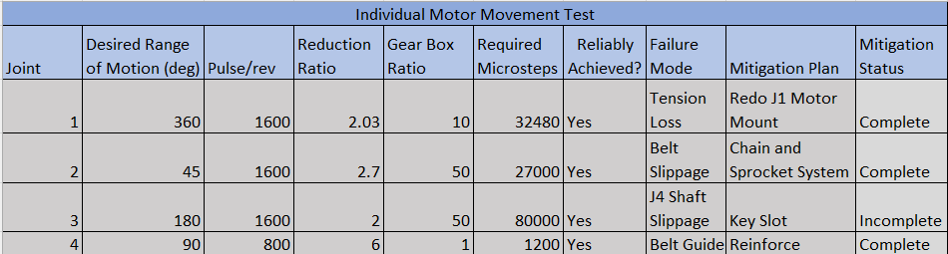

Specification Sheets
After the completion of all tests the specification sheets, showing a breakdown of the customer requirements as well and the engineering requirements, were then filled in. These two tables can be seen below, indicating what requirements were met and if they were client acceptable.

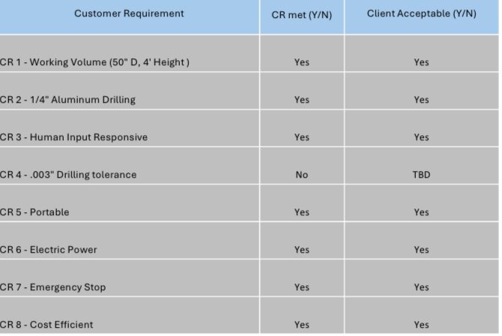
Table 8.2.5.1: Customer requirements specification sheet.

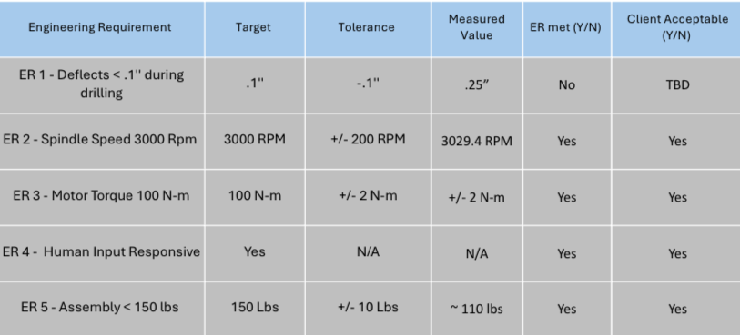
Table 8.2.5.2: Engineering Requirements specification sheet.

As seen within the tables all customer and engineering requirements did pass and were client acceptable, with the exception of drilling tolerance and deflection. Given that the tests were conducted on a flat plate of aluminum while the robot is designed for a cylindrical surface, these requirements are likely heavily impacted. The test is going to remain as shown, not passing, and further client meetings will allow the team to know whether this is acceptable for the client.

Future Work
For future work, the team has many ideas to better improve the robot's movement and efficiency. In programming, the focus lies on enhancing efficiency and user experience. The goal would be to develop a program adept at processing G-code files, streamlining the input process and improving compatibility. Additionally, we envision crafting an intuitive interface to simplify robot programming, ensuring accessibility and user-friendliness. In drilling operations, the objectives would extend towards versatility and precision. The plan would be to integrate a coolant spout for enhanced efficiency and tool longevity. Redesigning joints to accommodate varying working volumes will enhance adaptability, while enabling drilling in any direction, not just parallel to the ground, expands operational flexibility. Moreover, facilitating spindle functionality to change drill bits for diverse hole sizes will optimize performance. In terms of structural enhancements, our strategy involves replacing 3D printed components with aluminum counterparts to bolster structural rigidity, ensuring durability and reliability in operation.

Reflecting on this project, there are several key areas where we aim to implement changes for improved outcomes. Firstly, we recognize the importance of thorough research into electrical requirements and available programming software, ensuring compatibility and optimal functionality. Adopting a "bottom-up" design approach, rather than simultaneously designing individual joints, will facilitate a more cohesive and integrated system. Moreover, revisiting belt and pulley calculations will enhance accuracy and performance in motion transmission. Conducting extensive Finite Element Analysis (FEA) on parts will be pivotal in determining appropriate manufacturing materials, ensuring structural integrity and efficiency. Calculating torque requirements for varying arm positions while considering friction losses and desired acceleration will optimize operational performance. Exploring alternative options to the air-cooled spindle to decrease weight without compromising functionality will be a priority. Implementing better Design for Manufacture and Assembly (DFMA) tactics throughout the design process will streamline production and assembly. Lastly, we commit to thorough evaluation of options before execution, mitigating risks and maximizing project success.

CONCLUSIONS

In summary, the Northrop Grumman Robotic Drilling Arm team has successfully created a robotic drilling arm for Northrop Grumman Space Systems to help aid in drilling secondary structures for the launch vehicles their company designs. For the team to fully accomplish the assigned task, it was decided that creating a robotic arm with different bolt clearances, specific dimensions, and being fully autonomous was necessary. In doing this the team decided to use a reliable drilling system to have enough force to drill the composite material that these cylindrical components are made of within the competition, that being aluminum. The total budget had a high impact on what the team designed but given the flexibility that Northrop Grumman has allowed as can be seen throughout this paper, the team has made design choices that will ensure that the budget stayed within the maximum allotted $7500. The team’s fundraising of $750 was completed through the team’s GoFundMe page and personal contributions made by team and family members. Knowing how important this design can be for Northrop Grumman the team put in the maximum amount of effort towards the project’s success, leading to the team having a fully functional and state of the art design ready to present at Northrop Grumman Design Day.
The final design took time for the team to decide on as more information was discovered through mathematical modeling, benchmarking, customer constraints, engineering requirements and meeting with the clients. The team began thinking that it was necessary to design a robotic arm that included degrees of freedom, only to discover that this was much more complex than what was needed to succeed in the overall design. Following this the team also thought of designing a robotic arm that was similar to a Scara Robot which posed issues within deflection and accuracy, thus moving to a robotic arm with three degrees of freedom which in turn made it so the teams design could not adapt to the challenges it may face during day-to-day use. As a result, the team’s design of a four-degree freedom robotic drilling arm with spherical coordinates was reached. This design was great for the team at first, but after careful consideration, the linear actuators within this design were not practical given the knowledge the team has. After several different iterations of this design were considered mathematically impractical. The team’s final design was based off a pre-existing design from a company named Annin Robotics, whose design provided an excellent foundation for the team to base the final design off of.
This final design was a five degree of freedom robotic arm and was both scaled up and further modified from the Annin Robotics design as per the team’s needs. This design led to the manufacturing and assembly of a robotic drilling arm capable of rotating about its base in a full circle, full movement without any assistance, a reliable power draw, programmable instructions as to where the drill arm should orient itself, and can successfully drill through a plate of aluminum after orienting itself all in about three minutes. This design completed all that it was tasked with, having enough force, accuracy, and power to meet the constraints that have been put onto it. The team is satisfied that this design will continue to be the best possible choice for what the client needs to potentially use this in house and most importantly succeed at the Northrop Grumman Design Day.

REFERENCES
[1] “Robotstudio target external axis,” kasaplet. https://kasaplet.weebly.com/robotstudio-target-external-axis.html (accessed Oct. 08, 2023).

[2] “SCARA Robot | How To Build Your Own Arduino Based Robot,” www.youtube.com. https://www.youtube.com/watch?v=1QHJksTrk8s (accessed Oct. 20, 2022).

[3] “3D Printed Robots: The Most Advanced Projects of 2021,” All3DP, Sep. 11, 2021. https://all3dp.com/2/3d-printed-robot-print-robots/
[4] R. G. Budynas and J. K. Nisbett, “Chapter 9 - Welding, Bonding, and the Design of Permanent Joints,” in Shigley’s Mechanical Engineering Design, 11th edition, SI units, 11th ed, S.l., NY: MCGRAW-HILL EDUCATION (AS, 2020, pp. 485–612
[5] R. G. Budynas and J. K. Nisbett, “Chapter 4 - Deflection and Stiffness,” in Shigley’s Mechanical Engineering Design, 11th edition, SI units, 11th ed, S.l., NY: MCGRAW-HILL EDUCATION (AS, 2020, pp. 173–219
[6] G. R. Reddy and V. K. Eranki, “Design and Structural Analysis of a Robotic Arm,” thesis, Karlskrona, 2016
[7] R. Gautam, A. Gedam, A. Zade, and A. Mahawadiwar, Review on Development of Industrial Robotic Arm. International Research Journal of Engineering and Technology, 2017
[8] X. Zhang, M. Huang, M. Lei, H. Tian, X. Chen, and C. Tian, “Improved Rapid-Expanding-Random-Tree-Based Trajectory Planning on Drill ARM of Anchor Drilling Robots,” Machines, vol. 11, no. 9, p. 858, Aug. 2023, doi: 10.3390/machines11090858.
[9] M. Fairchild, “Drilling robots: Automate for fast and precise results,” #HowToRobot, https://howtorobot.com/expert-insight/drilling-robots (accessed Sep. 15, 2023).
[10] T. Xometry, “Drilling machines - parts, types, and uses,” Xometrys RSS, https://www.xometry.com/resources/machining/drilling-machines/ (accessed Sep. 15, 2023).
[11] R. Cheaytani, “Choosing the right drill bit,” Buying Guides DirectIndustry, https://guide.directindustry.com/choosing-the-right-drill-bit/ (accessed Dec. 1, 2023).
[12] A. Tyurnina, “Drill bit selection,” Inrock, https://www.inrock.com/drill-bit-selection/ (accessed Dec. 1, 2023).
[13] M. Lynch, “5 tips for selecting the optimal Spindle Range,” Modern Machine Shop, https://www.mmsonline.com/articles/5-tips-for-selecting-the-optimal-spindle-range (accessed Dec. 1, 2023).

[14] R. C. Hibbeler, ENGINEERING MECHANICS: dynamics. Pearson, 2018.
[15] R. G. Budynas, J Keith Nisbett, and Joseph Edward Shigley, Shigley’s mechanical engineering design. New York, Ny: Mcgraw-Hill Education, 2020.
[16] K. F. Tamrin, N. A. Sheikh, and S. M. Sapuan, “Laser drilling of composite material: A review,” ScienceDirect, Jan. 01, 2019.
[17] A. Haidar, C. Benachaiba, and M. Zahir, “Software interfacing of servo motor with microcontroller,” Faculty of Engineering and Information Sciences - Papers: Part A, Jan. 2013.I
[18] G.-S. Huang, C.-K. Tung, H.-C. Lin, and S.-H. Hsiao, “Inverse kinematics analysis trajectory planning for a robot arm,” IEEE Xplore, May 01, 2011.
[19] “Simulator for industrial robots and offline programming - RoboDK,” robodk.com.
[20] “Jeremy Fielding – All Things Mechanical,” Jeremy Fielding.
[21] “RCTESTFLIGHT,” RCTESTFLIGHT.
[22] tec-science, “How does a cycloidal drive work?,” tec-science, Jan. 14, 2019.
[23] R. G. BUDYNAS, “Gears- General,” in Shigley’s Mechanical Engineering Design, 11th ed, MCGRAW-HILL EDUCATION, 2019
[24] W. D. Callister and D. G. Rethwisch, “Mechanical Properties of Metals,” in Materials science and engineering: An introduction, 10th ed, Milton, QLD: John Wiley and Sons Australia, Ltd, 2021
[25] T. J. Baumeister, E. A. Avallone, and T. I. Baumeister, Standard Handbook for Mechanical Engineers, 7th ed. New York: McGraw-Hill Book, 1978.
[26] A. Bicchi and G. Tonietti, “Fast and ‘soft-arm’ tactics,” IEEE Robotics &amp; Automation Magazine, vol. 11, no. 2, pp. 22–33, 2004. doi:10.1109/mra.2004.1310939
[27] S. G. Yakovlev, J. K. Keldibekov, and I. M. Gorbachenko, “Software development for 3D visualization of G-code when working with CNC machines,” Journal of Physics: Conference Series, vol. 1515, no. 2, p. 022082, 2020. doi:10.1088/1742-6596/1515/2/022082
[28] “What is manufacturing & Manufacturing Processes,” Engineering Product Design, https://engineeringproductdesign.com/knowledge-base/manufacturing-processes/ (accessed Sep. 17, 2023).
[29] “Browse Catalog,” McMaster-Carr, https://www.mcmaster.com/ (accessed Sep. 17, 2023).
[30] T. Seo, G.-P. Jung, and D. Yun, Advances in Bio-Inspired Robots. S.l. Units: MDPI AG, 2021. Journals/Articles
[31] “Speed - torque curves for Stepper Motors,” Oriental Motor U.S.A. Corp., https://www.orientalmotor.com/stepper-motors/technology/speed-torque-curves-for-stepper-motors.html (accessed Nov. 29, 2023).
[32] B. J. Goodno and J. M. Gere, “Chapter 8: Deflection of Beams,” in Mechanics of Materials, vol. 11th, Australia: Cengage, 2021
[33] Springer Handbook of Robotics: With 84 Tables

[34] Chapter 11 – Implementation, in Engineering by design

[35] Development of Robotic Arm Prototype - A. Chaudhari, K. Rao, K. Rudrawar, P. Randhavan and P. Raut,

[36] A Review of Current Techniques for Robotic Arm Manipulation and Mobile Navigation - T. Sieusankar and B. Chandrasekaran, T. Sieusankar and B. Chandrasekaran

[37] Design of Geometric-Based Inverse Kinematics for a Low-Cost Robotic Arm - M. A. Muslim and S. N. Urfin

[38] The Demeter Project - How to Create a Robotic Arm With Your Students

[39] “Simplify Robot Programming with G-code - Universal Robots,”
[40] “Appendix E: Creating the validation plan with a validation requirements matrix,” NASA, https://www.nasa.gov/reference/appendix-e-creating-the-validation-plan-with-a-validation-requirements-matrix/ (accessed Nov. 29, 2023).
[41] P. Eskofier, “Drv8825 Adjust stepper current,” my home fab, https://www.my-home-fab.de/en/documentations/technical-descriptions/drv8825-adjust-stepper-current (accessed Nov. 14, 2023). .
[42] “Three golden rules for choosing a power supply (no maths!) - tutorial australia,” Core Electronics, https://core-electronics.com.au/guides/power-supply-which-to-choose/ (accessed Nov. 29, 2023).
[43] R. G. Budynas and J. K. Nisbett, “Chapter 5- Failure Resulting from Static Loading,” in Shigley’s
Mechanical Engineering Design, 11th edition, SI units, 11th ed, S.l., NY: MCGRAW-HILL
EDUCATION (AS, 2020, pp. 241-275)
[44] R. G. Budynas and J. K. Nisbett, “Chapter 18 – Power Transmission Case Study,” in Shigley’s
Mechanical Engineering Design, 11th edition, SI units, 11th ed, S.l., NY: MCGRAW-HILL
EDUCATION (AS, 2020, pp. 937-953)
[45] A. Imran and B.-J. Yi, “Performance Analysis of 7-DOF Robotic Arm for Drilling and Milling
Applications,” Performance Analysis of 7-DOF Robotic Arm for Drilling and Milling
Applications, Jun. 2018, doi: 10.1109/urai.2018.8441826.
[46] Garnier, Sebastien & Subrin, Kévin & Waiyagan, Kriangkrai. (2017). Modeling of Robotic Drilling.
Procedia CIRP. 58. 416-421. 10.1016/j.procir.2017.03.246.
[47] Jinho, Lee & Hong, Taehwa & Seo, Chang-Hoon & Jeon, Yong & Lee, Moon & Kim, Hyo-Young.
(2021). Implicit force and position control to improve drilling quality in CFRP flexible roboticmachining. Journal of Manufacturing Processes. 68. 1123-1133.10.1016/j.jmapro.2021.06.038
[48] “DatasheetDirectory,” Globalspec.com,2020. https://www.globalspec.com/specsearch/partspecs?partI
[49] “Free CAD Designs, Files & 3D Models | The GrabCAD Community Library.” https://grabcad.com/library/slewing-rings-2”
[50] P. & C. Llc. A. R. Reserved, “Slew Drive SlewPro.” https://www.slewpro.com/products/slewing-drives
[51] “Annin Robotics,” Annin Robotics. https://www.anninrobotics.com/
[52] “ThinSectionBearingsforIndustrialRobotsRBCThinSectionBallBearings:BecauseThat’sHowWeRoll.I
ndustrialRobotApplications:•HumanAssist•Medical•Paintspray•Pickandplace•Semiconductor-
Vacuum -Atmos pheri c • Wel ding.” Accessed: Oct. 09, 2023. [Online]. Ava ilable: https
://www.rbcbearings.com/literature/pdfs/ThinSect_Ro bots_3_28_16.pdf
[52] Chapter 12 – Lubrication and Journal Bearings, Shigley’s Mechanical Engineering Design
[53] Chapter 20 – Geometric Dimensioning and Tolerancing, Shigley’s Mechanical Engineering Design
[55] ASME Y14.100 - 2004
[56] ASME Y14.24 - 2012
[57] Fancu Arc Mate 0iA Robot
[58] ABB IRB 1600ID Robot
[59] High Quality Equipment and Tool with Unbeatable Price
[60] B. J. Goodno and J. M. Gere, “Chapter 3: Torsion,” in Mechanics of Materials, vol. 11th, Australia: Cengage, 2021
[61] Holding Torque – Science Direct

APPENDICES

Appendix A: Top Level Testing Design Summary

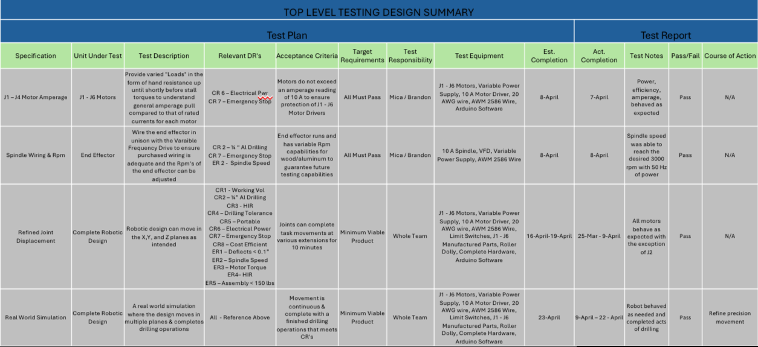
Table 12.1.1: Top level testing design summary.

Appendix B: Bill of Materials
Table 12.2.1: Complete Manufactured Bill of Materials
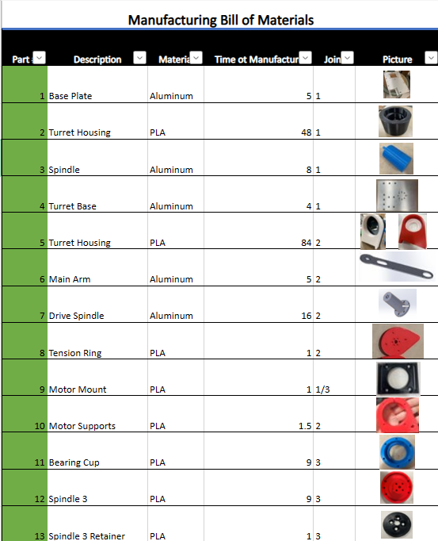
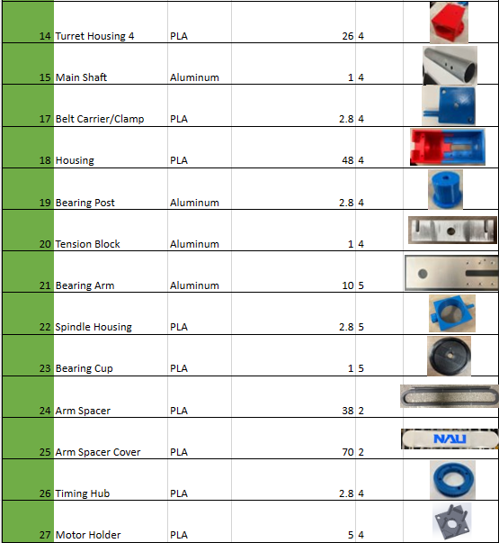

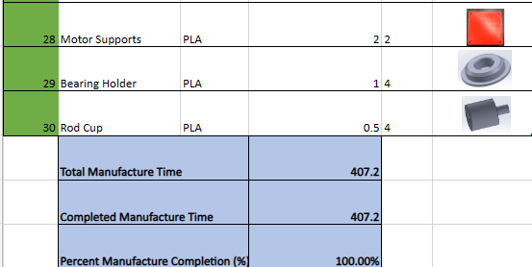

Table 12.2.2: Complete Purchasing Bill of Materials
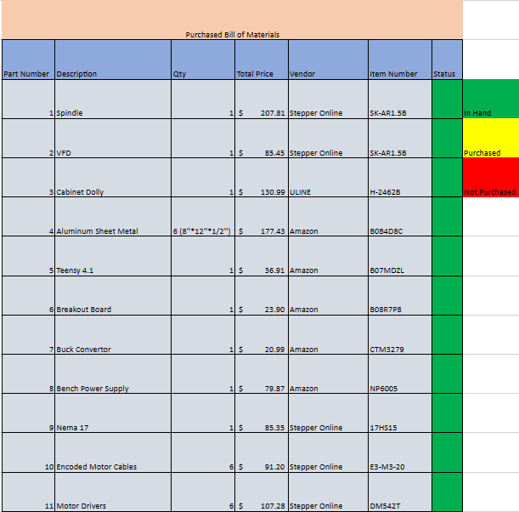

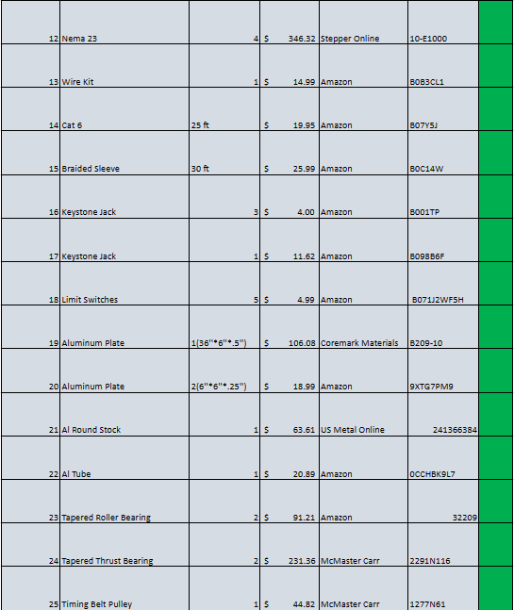
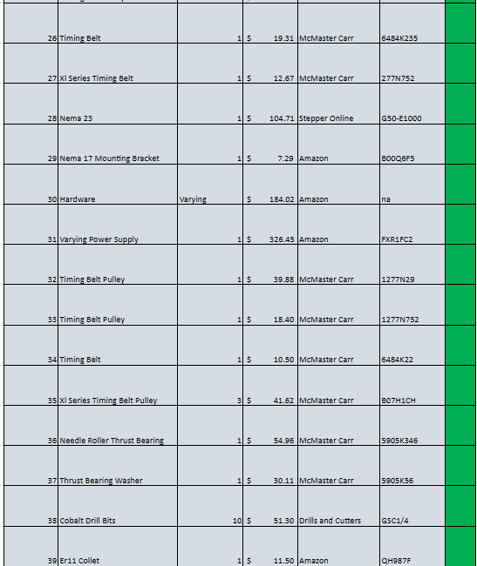
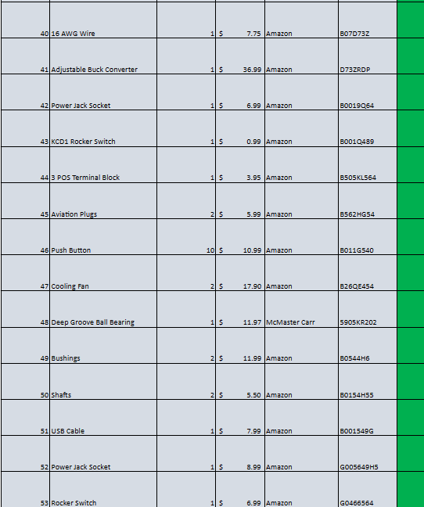
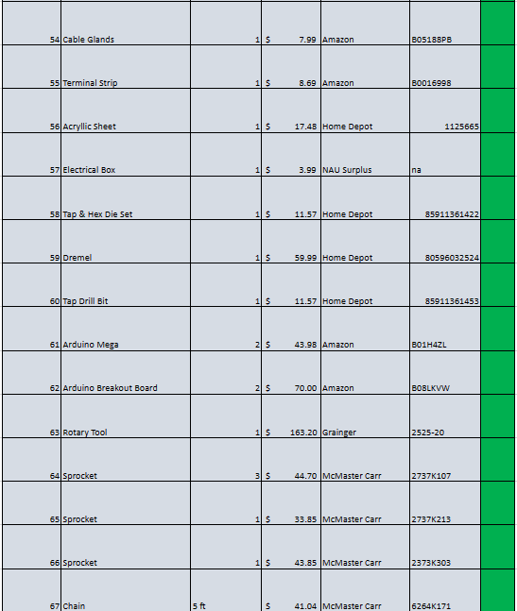


Appendix C: Failure Modes and Effects Analysis
Table 12.3.1: FMEA for Joints One and Two
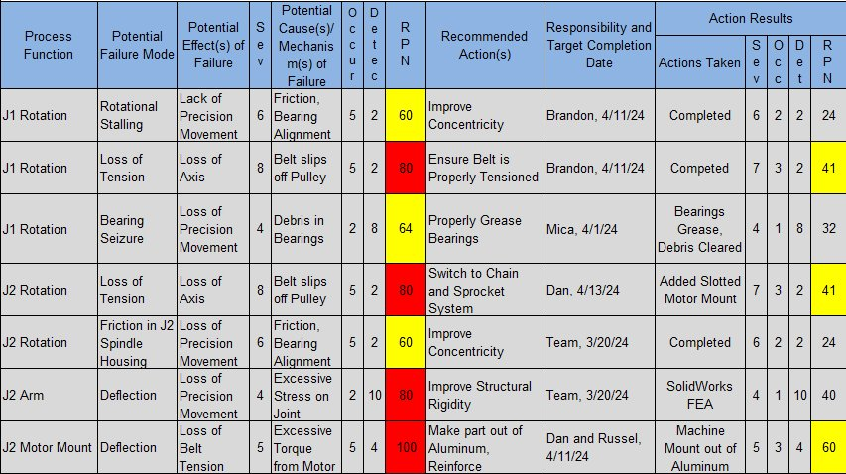
Table 12.3.2: FMEA for Joints Three and Four
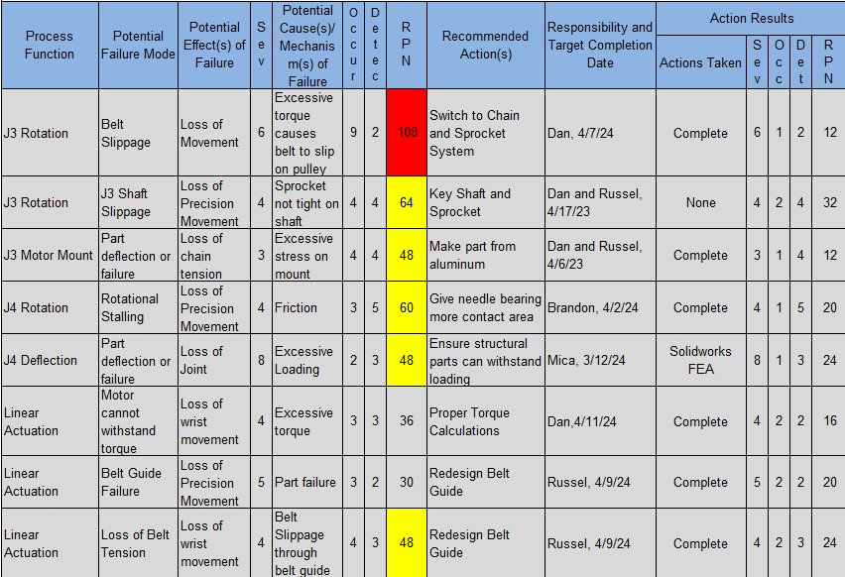

Table 12.3.3: FMEA for Joint Five and Spindle
